- Research about the topic
I will research about the application programs using as Social media connecting

- Topic title
Instagram software application

- What is it?
Social media is a mobile photo-sharing application and service that allows users to share pictures and videos

- Where is it Used?
Using by smart phone, or internet through laptop or desktop PC.
- How ….
By sharing pictures and video either publicly or privately on the service, as well as through a variety of other social networking platforms, such as Facebook.
- Example…
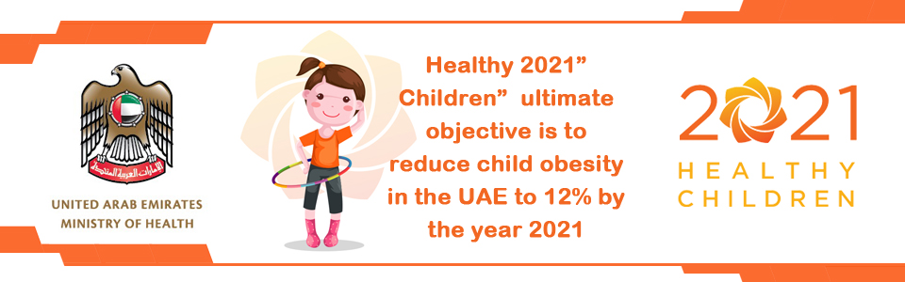

- Connection to the or world your community
This is my private account in the social media like facebook.com and Instagram are having weekly articles about health and Fitness.

- Connection to you
I have useful to read and write at my health social account. In future I planning to be a doctors.

- Why is it used?
I used the facebook.com and used the instegram.com the first one for text then picture, the second for pictures then little text.

- Your opinion about it consumer weekly blog prompt / questions).
- I it is very useful.
- It has a lot information's about health.
- Updates every weekly.

- How much time do teenagers in the world spend on social media?
World report: Teens spend a 9 hours a day using media
UAE: teens spend more than 6 hours a day using media
Girls using social media more than boy

- Which social media applications do teenagers use?
Facebook – twitter – Instagram – snapchat – kik

13- Sources:
[1] - http://edition.cnn.com/2015/11/03/health/teens-tweens-media-screen-use-report/, By Kelly Wallace, CNN, Updated 0207 GMT (1007 HKT) November 4, 2015

[2] - http://www.socialmediatoday.com/marketing/how-much-time-do-people-spend-social-media-infographic, January 04, 2017 Evan Asano

[3] - http://www.thenational.ae/uae/technology/20170130/trends-in-uaes-social-media-usage-revealed

