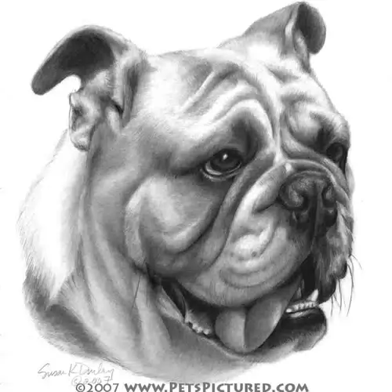
Draft 1 The annoying bull dog
In my opinion dogs are the most disgusting mammal on land . Some dogs are cute , beautiful and nice . Others are huge , ugly , fast , powerful and disgusting , such as bull dog . Some people use `dog in competitions sports and guard houses and acts of war, police and many other actions are difficult to count. And the dog more animals love and loyalty to man. Its really unpleasant kind of dog .

It has four short legs Also , short tail . It really a heavy dog . It has facial wrinkles and hairy body . It has short body , And long curly face . It has pointed teeth . It has folds of skin in his face . It has black wide eye . It eat soya bean and it is a species of legume native to East Asia, widely grown .

Most people don’t like bull dogs because its disgusting , powerful and scary .It really annoying and ugly . It live in England * united kingdom *. There are many specious of bull dog .First : english bull dog , wish the average hight was approximately Fifteen inches . Second : French bull dog , wish it survive from eight to ten years . third: American bull dog , while it survive from ten to Fifteen years .

Finally Bulldogs are the 5th most popular purebreed in the United States in 2013 according to the American Kennel Club . I really feel a sense of Disgusting when I see bull dog ,but I don’t scared from this kind of mammal . I gust scared from this type of dog . We've got names for Bulldogs, both girls and boys, which fit the breed's down-to-earth personality and build. ( Jessie , Stella , Bubba , Sadie )
Almaha Faisal .
10-2 .

