

English research about

Loud and Unusual

Name:
Grade: 12 "
Supervised by:

The wildlife is full of different species of animals. Each one got its features. In this research, I will talk about the mystery of the jungle, and three kinds of animals, the Hyena dog, the elephant, and the American Alligator.
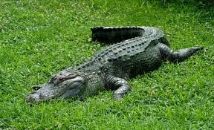

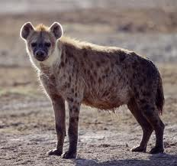
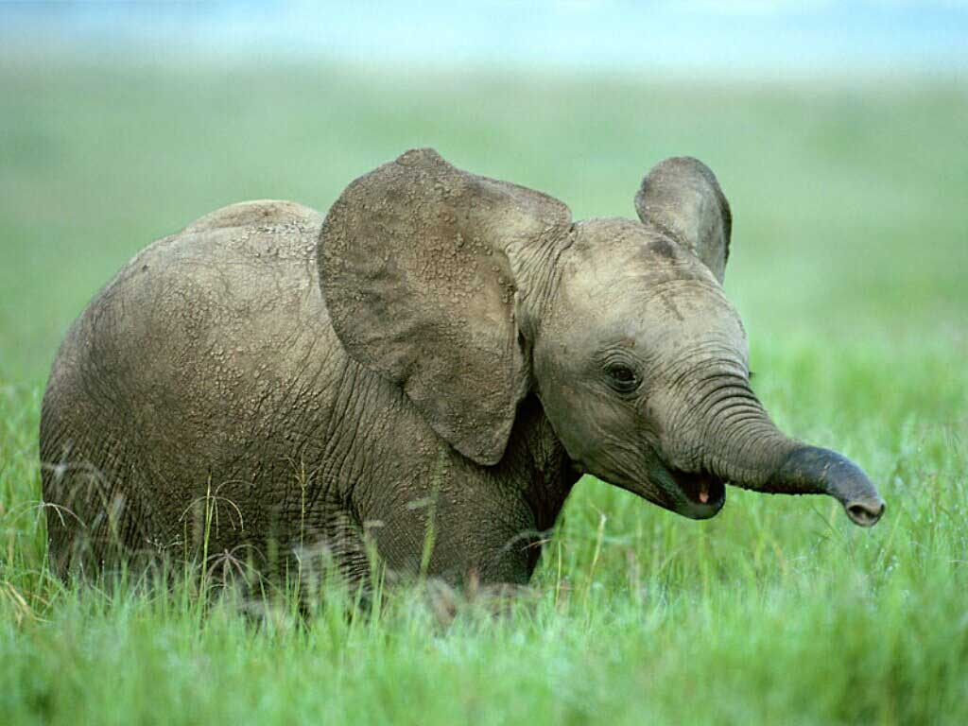

Mystery of the jungle

In an insect-infested, hot, humid and dense jungle, far away from anywhere with running water, electricity, or roads, lie over 16 enormous ancient monuments. After battling for days through the steamy Mexican swamp (chopping their way through thick trees and bushes, while always on the look-out for snakes), archaeologists were confronted by a strange sight: three-meter-tall stone monuments weighting up to 27 metric tons.



Imprint of a cylindrical stamp found at San Andrés, Tabasco. The bird is “speaking” glyphs that include the name 3 Ahau, possibly the name of a chief.
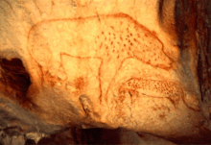

Animals were used in the pictographs on this sight, and other sights. For example, hyena pictures were found on some sights painted on the walls and stones.

The hyena dog

Hyenas or Hyaenas (from Greek "ὕαινα" - hýaina) are the animals of the family Hyaenidae of suborder feliforms of the Carnivora. It is the fourth smallest biological family in the Carnivora (consisting of four species), and one of the smallest in the mammalia. Despite their low diversity, hyenas are unique and vital components to most African and some Asian ecosystems.
Hyenas first arose in Eurasia during the Miocene period from viverrid-like ancestors, and developed into two distinct branches; the lightly built dog-like hyenas and the robust bone-crushing hyenas. Although the dog-like hyenas thrived 15 million years ago (with one taxon having colonized North America), they died out after a change in climate along with the arrival of canids into Eurasia. Of the dog-like hyena lineage, only the insectivorous aardwolf survived, while the bone-crushing hyenas (whose extant members are the spotted, brown and striped hyena) became the undisputed top scavengers of Eurasia and Africa.

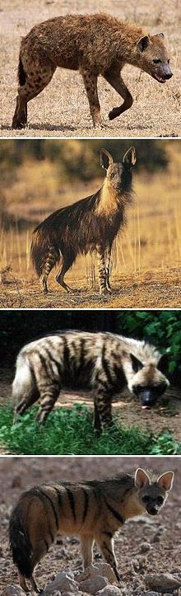
Hyenas feature prominently in the folklore and mythology of human cultures with which they are sympatric. Hyenas are mostly viewed with fear and contempt, as well as being associated with witchcraft, as their body parts are used as ingredients in traditional medicine. Among the beliefs held by some cultures, hyenas are thought to influence people’s spirits, rob graves, and steal livestock and childr en

Behavior

Hyenas groom themselves often like felids and viverrids, and their way of licking their genitals is very cat-like (sitting on the lower back, legs spread with one leg pointing vertically upward). However, unlike other feliforms, they do not "wash" their faces. They defecate in the same manner as other Carnivora, though they never raise their legs as canids do when urinating, as urination serves no territorial function for them. Instead, hyenas mark their territories using their anal glands, a trait found also in viverrids and mustelids, but not canids and felids. When attacked by lions or dogs, stripedand brown hyenaswill feign death, though the spotted hyena will defend itself ferociously. The spotted hyena is very vocal, producing a number of different sounds consisting of whoops, grunts, groans, lows, giggles, yells, growls, laughs and whines. The striped hyena is comparatively silent, its vocalisations being limited to a chattering laugh and howling.

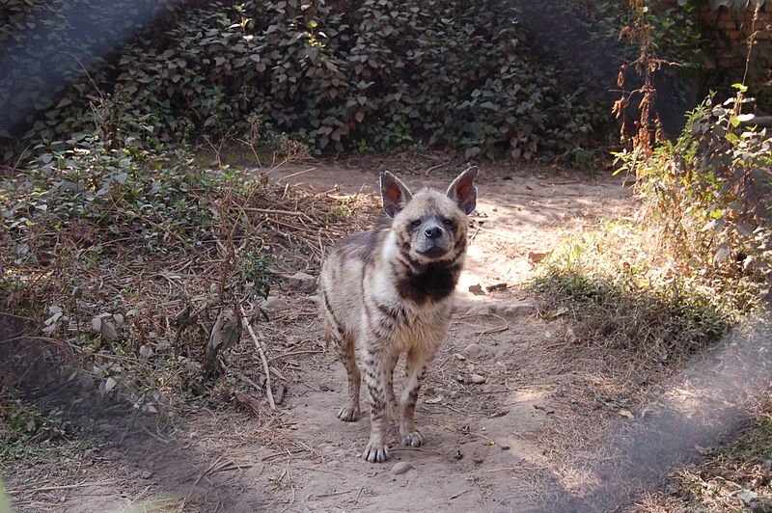
The striped hyena is primarily a scavenger, though it will occasionally attack and kill any defenseless animal it can overcome, and will supplement its diet with fruit. The spotted hyena, though it also scavenges occasionally, is an active pack hunter of medium to large sized ungulates, which it catches by wearing them down in long chases and dismembering them in a canid-like manner. The aardwolf is primarily an insectivore, specialised for feeding on termites of the genus Trinervitermes and Hodotermes, which it consumes by licking them up with its long, broad tongue. An aardwolf can eat 300,000 Trinervitermes on a single outing. Hyenas are also known for their characteristic calls which sound like laughs.

The American alligatour

The American alligator (Alligator mississippiensis), sometimes referred to colloquially as a gator or common alligator, is a large crocodilian reptile endemic to the Southeastern United States. It is one of two living species in the genus Alligator within the family Alligatoridae and larger than the other extant alligator species, the Chinese alligator. The American alligator inhabits freshwater wetlands, such as marshes and cypress swamps from Texas to North Carolina. It is distinguished from the sympatric American crocodile by its broader snout, with overlapping jaws and darker coloration, and is less tolerant of seawater but more tolerant of colder climates.
It is listed as Least Concern by the International Union for Conservation of Nature. Historically, hunting has decimated their population and it was listed as an endangered species by the Endangered Species Act of 1973. Subsequent conservation efforts have allowed their numbers to increase and the species was removed from the list in 1987. Alligators are now harvested for their skins and meat. The species is the official state reptile of three states: Florida, Louisiana and Mississippi.
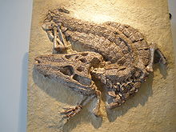
Taxonomy and phylogeny

The American alligator was first classified by French zoologist François Marie Daudin as Crocodilusmississipiensis in 1801. Georges Cuvier classified the genus Alligator in 1807.The American alligator shares this genus with the Chinese alligator. They are grouped in the family Alligatoridae with the caimans. The superfamily Alligatoroidea includes all crocodilians (fossil and extant) that are more closely related to the American alligator than to either the Nile crocodile or the gharial.

Description

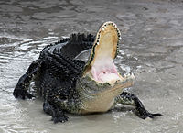
An alligator can live up to 30 to 50 years. In adult male American alligators, length averages 3.4 m (11 ft) while in smaller females, it averages 2.6 m (8.5 ft). Occasionally, a large, old male may measure in excess of 4 m (13 ft). There have been reports during the 19th and 20th centuries of larger males reaching 5 to 6 m (16 to 20 ft). The largest reported size was a male killed in 1890 on Marsh Island, Louisiana and reportedly measured at 5.8 m (19 ft) in length but no voucher specimen was available since the alligator was left on a muddy bank after having been taped due to having been too massive to relocate. Adult males may weigh around 227 kg (500 lb) while females weigh around 91 kg (200 lb). Wild alligators range from long and slender to short and robust, possibly due to variations in factors like growth rate, diet and climate. Alligators have broad snouts, especially in captive individuals. When the jaws are closed, the edge of the upper jaws covers the lower teeth which fit into the jaws' depressions. Like the spectacled caiman, this species has a bony nasal ridge, though it is less prominent. Dorsally, adult alligators may be olive, brown, gray or black in color while their undersides are cream colored. The teeth number from 74–84

Habitat

American alligators are only found in the Southeastern United States, from Great Dismal Swamp in North Carolina, south to Everglades National Park in Florida and west to the southern tip of Texas. They are found in the U.S. states of North Carolina, South Carolina, Georgia, Florida, Louisiana, Alabama, Mississippi, Arkansas, Texas, and Oklahoma. Alligators inhabit swamps, streams, rivers, ponds and lakes. Females and juveniles are also found in Carolina Bays and other seasonal wetlands. While they prefer freshwater, alligators sometimes enter more brackish water. However they are less tolerant of saltwater than crocodiles as the salt glands on their tongues are non-functioning. One study of alligators in north-central Florida found that males preferred open lake water during the spring while females used both swampy and open water areas. During summer, males still preferred open water while females stuck to the swamps to construct their nests and lay their eggs. Both sexes may den underneath banks or clumps of trees during the winter.
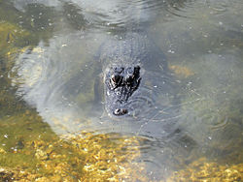
American alligators are less vulnerable to cold than American crocodiles. (7.2 °C) an alligator can survive in such temperatures for some time without any signs of discomfort. It is thought that this adaptiveness is the reason why American alligators spread farther north than the American crocodile. In fact, the American alligator is found farther from the equator and is more equipped to deal with cooler conditions than any other crocodilian. When the water begins to freeze, alligators stick their snouts though the surface which allows them to breathe above the ice.

The Elephant

Elephants are large mammals of the family Elephantidae and the order Proboscidea. Traditionally, two species are recognised, the African elephant (Loxodontaafricana) and the Asian elephant (Elephasmaximus), although some evidence suggests that African bush elephants and African forest elephants are separate species (L. africana and L. cyclotis respectively). Elephants are scattered throughout sub-Saharan Africa, and South and Southeast Asia. They are the only surviving proboscideans; extinct species include mammoths and mastodons. The largest living terrestrial animals, male African elephants can reach a height of 4 m (13 ft) and weigh 7,000 kg (15,000 lb). These animals have several distinctive features, including a long proboscis or trunk used for many purposes, particularly for grasping objects. Their incisors grow into tusks, which serve as tools for moving objects and digging and as weapons for fighting. The elephant's large ear flaps help to control the temperature of its body. African elephants have larger ears and concave backs while Asian elephants have smaller ears and convex or level backs.

Elephants are herbivorous and can be found in different habitats including savannahs, forests, deserts and marshes. They prefer to stay near water. They are considered to be keystone species due to their impact on their environments. Other animals tend to keep their distance, and predators such as lions, tigers, hyenas and wild dogs usually target only the young elephants (or "calves"). Females (or "cows") tend to live in family groups, which can consist of one female with her calves or several related females with offspring. The latter are led by the oldest cow, known as the matriarch. Elephants have a fission-fusion society in which multiple family groups come together to socialise. Males (or "bulls") leave their family groups when they reach puberty, and may live alone or with other males. Adult bulls mostly interact with family groups when looking for a mate and enter a state of increased testosterone and aggression known as musth, which helps them gain dominance and reproductive success. Calves are the centre of attention in their family groups and rely on their mothers for as long as three years. Elephants can live up to 70 years in the wild. They communicate by touch, sight, and sound; elephants use infrasound, and seismic communication over long distances. Elephant intelligence has been compared with that of primates and cetaceans. They appear to have self-awareness and show empathy for dying or dead individuals of their kind.

African elephants are listed as vulnerable by the International Union for Conservation of Nature (IUCN), while the Asian elephant is classed as endangered. One of the biggest threats to elephant populations is the ivory trade, as the animals are poached for their ivory tusks. Other threats to wild elephants include habitat destruction and conflicts with local people. Elephants are used as working animals in Asia. In the past they were used in war; today, they are often put on display in zoos and circuses. Elephants are highly recognisable and have been featured in art, folklore, religion, literature and popular culture.

Ears

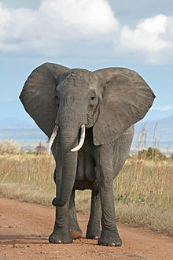
Elephant ears have thick bases with thin tips. The ear flaps, or pinnae, contain numerous blood vessels called capillaries. Warm blood flows into the capillaries, helping to lose excess body heat into the environment. This occurs when the pinnae are still, and the animal can enhance the effect by flapping them. Larger ear surfaces contain more capillaries, and more heat can be released. Of all the elephants, African bush elephants live in the hottest climates, and have the largest ear flaps. Elephants are capable of hearing at low frequencies and are most sensitive at 1 kHz.

Trunk

The trunk, or proboscis, is a fusion of the nose and upper lip, although in early fetal life, the upper lip and trunk are separated. The trunk is elongated and specialised to become the elephant's most important and versatile appendage. It contains up to 150,000 separate muscle fascicles, with no bone and little fat. These paired muscles consist of two major types: superficial (surface) and internal. The former are divided into dorsals, ventrals and laterals, while the latter are divided into transverse and radiating muscles. The muscles of the trunk connect to a bony opening in the skull. The nasal septum is composed of tiny muscle units that stretch horizontally between the nostrils. Cartilage divides the nostrils at the base. As a muscular hydrostat, the trunk moves by precisely coordinated muscle contractions. The muscles work both with and against each other. A unique proboscis nerve—formed by the maxillary and facial nerves—runs along both sides of the trunk.

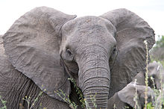
Elephant trunks have multiple functions, including breathing, olfaction, touching, grasping, and sound production. The animal's sense of smell may be four times as sensitive as that of a bloodhound. The trunk's ability to make powerful twisting and coiling movements allows it to collect food, wrestle with conspecifics, and lift up to 350 kg (770 lb). It can be used for delicate tasks, such as wiping an eye and checking an orifice, and is capable of cracking a peanut shell without breaking the seed. With its trunk, an elephant can reach items at heights of up to 7 m (23 ft) and dig for water under mud or sand. Individuals may show lateral preference when grasping with their trunks: some prefer to twist them to the left, others to the right. Elephants can suck up water both to drink and to spray on their bodies. An adult Asian elephant is capable of holding 8.5 L (2.2 USgal) of water in its trunk. They will also spray dust or grass on themselves. When underwater, the elephant uses its trunk as a snorkel.

The African elephant has two finger-like extensions at the tip of the trunk that allow it to grasp and bring food to its mouth. The Asian elephant has only one, and relies more on wrapping around a food item and squeezing it into its mouth. Asian elephants have more muscle coordination and can perform more complex tasks. Losing the trunk would be detrimental to an elephant's survival, although in rare cases individuals have survived with shortened ones. One elephant has been observed to graze by kneeling on its front legs, raising on its hind legs and taking in grass with its lips. Floppy trunk syndrome is a condition of trunk paralysis in African bush elephants caused by the degradation of the peripheral nerves and muscles beginning at the tip.

Teeth

Elephants usually have 26 teeth: the incisors, known as the tusks, 12 deciduous premolars, and 12 molars. Unlike most mammals, which grow baby teeth and then replace them with a single permanent set of adult teeth, elephants have cycles of tooth rotation throughout their lives. The chewing teeth are replaced six times in a typical elephant's lifetime. Teeth are not replaced by new ones emerging from the jaws vertically as in most mammals. Instead, new teeth grow in at the back of the mouth and move forward to push out the old ones, similar to a conveyor belt. The first chewing tooth on each side of the jaw falls out when the elephant is two to three years old. The second set of chewing teeth falls out when the elephant is four to six years old. The third set is lost at 9–15 years of age, and set four lasts until 18–28 years of age. The fifth set of teeth lasts until the elephant is in its early 40s. The sixth (and usually final) set must last the elephant the rest of its life. Elephant teeth have loop-shaped dental ridges, which are thicker and more diamond-shaped in African elephant.
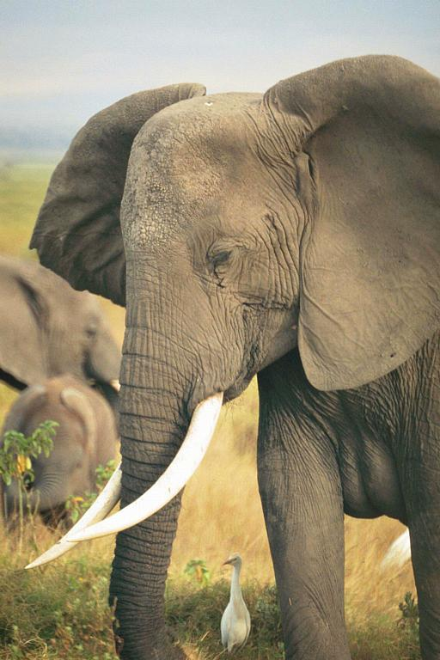
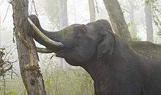
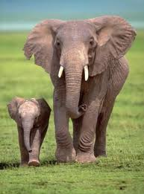

The resources

1- Encyclopedia ( Wikipedia )

2-This is what they call pets in Africa - By Spooky on March 1st, 2008 Category: Animals, Pics

3- The White Bone - by Barbara Gowdy

