
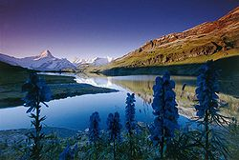

دولة الامارات العربية المتحدة.
وزارة التربــــــــــــــــــــــــية والتعلــــــــــــــــــــــــــــيم.
منطقة ..................................
مدرســــــــــــــة ................................
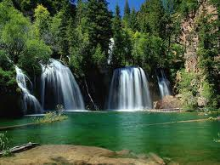
paragraph about: -

Done by: ........................... .
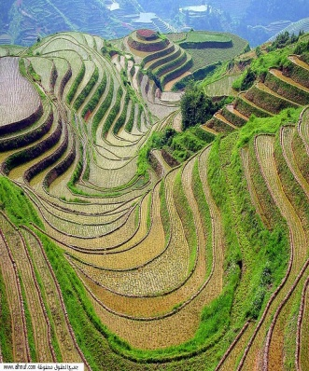
Date: .................
Teacher: ............................
Class:.........

Report schedule:-
page | content
1 | Start page
2 | Report schedule
3 | Introduction-Earth-Ecosystems
4 | Evolution- animals and planets
5 | Water on Earth
5 | Conclusion
5 | Resource and References

Introduction:-
Nature, in the broadest sense, is equivalent to the natural world, physical world, or material world. "Nature" refers to the phenomena of the physical world, and also to life in general. It ranges in scale from the subatomic to the cosmic.
Earth:-
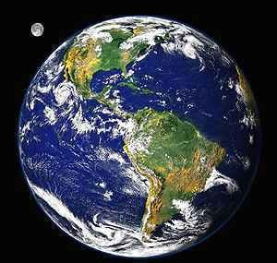
Earth (or, "the earth") is the only planet presently known to support life, and its natural features are the subject of many fields of scientific research. Within the solar system, it is third closest to the sun; it is the largest terrestrial planet and the fifth largest overall. Its most prominent climatic features are its two large polar regions, two relatively narrow temperate zones, and a wide equatorial tropical to subtropical region.^{[6]} Precipitation varies widely with location, from several metres of water per year to less than a millimetre. 71 percent of the Earth's surface is covered by salt-water oceans. The remainder consists of continents and islands, with most of the inhabited land in the Northern Hemisphere.
Earth has evolved through geological and biological processes that have left traces of the original conditions. The outer surface is divided into several gradually migrating tectonic plates. The interior remains active, with a thick layer of plastic mantle and an iron-filled core that generates a magnetic field.
The atmospheric conditions have been significantly altered from the original conditions by the presence of life-forms,^{[7]} which create an ecological balance that stabilizes the surface conditions. Despite the wide regional variations in climate by latitude and other geographic factors, the long-term average global climate is quite stable during interglacial periods,^{[8]} and variations of a degree or two of average global temperature have historically had major effects on the ecological balance, and on the actual geography of the Earth.

Ecosystems:-
Ecosystems are composed of a variety of abiotic and biotic components that function in an interrelated way.^{[39]} The structure and composition is determined by various environmental factors that are interrelated. Variations of these factors will initiate dynamic modifications to the ecosystem. Some of the more important components are: soil, atmosphere, radiation from the sun, water, and living organisms.
Central to the ecosystem concept is the idea that living organisms interact with every other element in their local environment. Eugene Odum, a founder of ecology, stated: "Any unit that includes all of the organisms (ie: the "community") in a given area interacting with the physical environment so that a flow of energy leads to clearly defined trophic structure, biotic diversity, and material cycles (i.e.: exchange of materials between living and nonliving parts) within the system is an ecosystem."^{[40]} Within the ecosystem, species are connected and dependent upon one another in the food chain, and exchange energy and matter between themselves as well as with their environment.^{[41]} The human ecosystem concept is grounded in the deconstruction of the human/nature dichotomy and the premise that all species are ecologically integrated with each other, as well as with the abiotic constituents of their biotope.
A smaller unit of size is called a microecosystem. For example, a microsystem can be a stone and all the life under it. A macroecosystem might involve a whole ecoregion, with its drainage basin.

Evolution:-
Life is only known to exist on the planet Earth.(cf Astrobiology) The origin of life is still a poorly understood process, but it is thought to have occurred about 3.9 to 3.5 billion years ago during the hadean or archean eons on a primordial earth that had a substantially different environment than is found at present.^{[58]} These life forms possessed the basic traits of self-replication and inheritable traits. Once life had appeared, the process of evolution by natural selection resulted in the development of ever-more diverse life forms.
Species that were unable to adapt to the changing environment and competition from other life forms became extinct. However, the fossil record retains evidence of many of these older species. Current fossil and DNA evidence shows that all existing species can trace a continual ancestry back to the first primitive life forms.^{[58]}
The advent of photosynthesis in very basic forms of plant life worldwide allowed the sun's energy to be harvested to create conditions allowing for more complex life.^{[citation needed]} The resultant oxygen accumulated in the atmosphere and gave rise to the ozone layer. The incorporation of smaller cells within larger ones resulted in the development of yet more complex cells called eukaryotes.^{[59]} Cells within colonies became increasingly specialized, resulting in true multicellular organisms. With the ozone layer absorbing harmful ultraviolet radiation, life colonized the surface of Earth.

Plants and animals:-

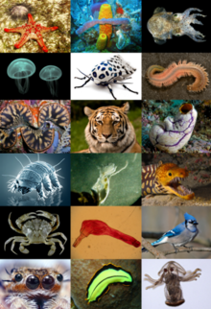
Originally Aristotle divided all living things between plants, which generally do not move fast enough for humans to notice, and animals. In Linnaeus' system, these became the kingdoms Vegetabilia (later Plantae) and Animalia. Since then, it has become clear that the Plantae as originally defined included several unrelated groups, and the fungi and several groups of algae were removed to new kingdoms. However, these are still often considered plants in many contexts. Bacterial life is sometimes included in flora,^{[64][65]} and some classifications use the term bacterial flora separately from plant flora.
Among the many ways of classifying plants are by regional floras, which, depending on the purpose of study, can also include fossil flora, remnants
of plant life from a previous era. People in many regions and countries take great pride in their individual arrays of characteristic flora, which can vary widely across the globe due to differences in climate and terrain.
Regional floras commonly are divided into categories such as native flora and agricultural and garden flora, the lastly mentioned of which are intentionally grown and cultivated. Some types of "native flora" actually have been introduced centuries ago by people migrating from one region or continent to another, and become an integral part of the native, or natural flora of the place to which they were introduced. This is an example of how human interaction with nature can blur the boundary of what is considered nature.
Another category of plant has historically been carved out for weeds. Though the term has fallen into disfavor among botanists as a formal way to categorize "useless" plants, the informal use of the word "weeds" to describe those plants that are deemed worthy of elimination is illustrative of the general tendency of people and societies to seek to alter or shape the course of nature. Similarly, animals are often categorized in ways such as domestic, farm animals, wild animals, pests, etc. according to their relationship to human life.
Animals as a category have several characteristics that generally set them apart from other living things. Animals are eukaryotic and usually multicellular (although see Myxozoa), which separates them from bacteria, archaea and most protists. They are heterotrophic, generally digesting food in an internal chamber, which separates them from plants and algae. They are also distinguished from plants, algae, and fungi by lacking cell walls.
With a few exceptions, most notably the sponges (Phylum Porifera), animals have bodies differentiated into separate tissues.^{[citation needed]} These include muscles, which are able to contract and control locomotion, and a nervous system, which sends and processes signals. There is also typically an internal digestive chamber. The eukaryotic cells possessed by all animals are surrounded by a characteristic extracellular matrix composed of collagen and elastic glycoproteins. This may be calcified to form structures like shells, bones, and spicules, a framework upon which cells can move about and be reorganized during development and maturation, and which supports the complex anatomy required for mobility.

Water on Earth:-

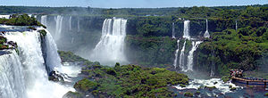
Water is a chemical substance that is composed of hydrogen and oxygen and is vital for all known forms of life.^{[27]} In typical usage, water refers only to its liquid form or state, but the substance also has a solid state, ice, and a gaseous state, water vapor or steam. Water covers 71% of the Earth's surface.^{[28]} On Earth, it is found mostly in oceans and other large water bodies, with 1.6% of water below ground in aquifers and 0.001% in the air as vapor, clouds (formed of solid and liquid water particles suspended in air), and precipitation.^{[29]} Oceans hold 97% of surface water, glaciers and polar ice caps 2.4%, and other land surface water such as rivers, lakes and ponds 0.6%. Additionally, a minute amount of the Earth's water is contained within biological bodies and manufactured products.

Conclusion:-

Finally. We must love nature. And protect him. We must not through dits on trees and on rivers
But we must implants trees and shoots and we must do others things to keep our nature.

Source:-
*NAT GEO.com
*Wikipedia-free encyclopidia.com
*UAE English skills-Grade nine

