بسم الله الرحمن الرحيم

تقرير بعنوان
Graphic design

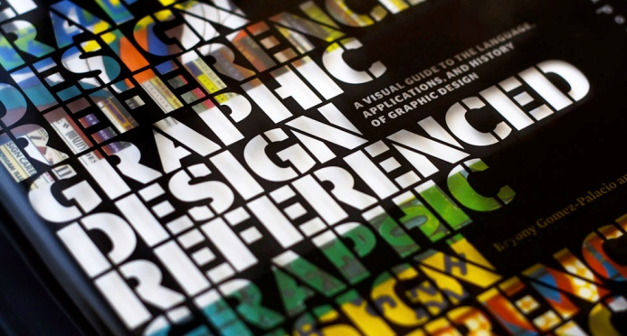

الاسم :
الصف : الثامن
المادة : الحاسوب
المدرسه :
المعلمة :
Introduction:
Graphic design is a creative process—most often involving a client and a designer and usually completed in conjunction with producers of form (i.e., printers, sign makers, etc.)—undertaken in order to convey a specific message (or messages) to a targeted audience. The term "graphic design" can also refer to a number of artistic and professional disciplines that focus on visual communication and presentation. The field as a whole is also often referred to as Visual Communication or Communication Design. Various methods are used to create and combine words, symbols, and images to create a visual representation of ideas and messages. A graphic designer may use a combination of typography, visual arts and page layout techniques to produce the final result. Graphic design often refers to both the process (designing) by which the communication is created and the products (designs) which are generated.
graphic design done by me
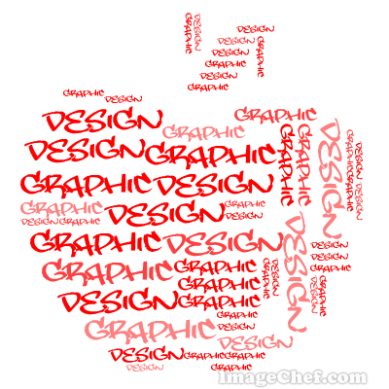
Subject:
During the Tang Dynasty (618–907) between the 4th and 7th century AD, wood blocks were cut to print on textiles and later to reproduce Buddhist texts. A Buddhist scripture printed in 868 is the earliest known printed book. Beginning in the 11th century, longer scrolls and books were produced using movable type printing making books widely available during the Song dynasty (960–1279).^{[4]} Sometime around 1450, Johann Gutenberg's printing press made books widely available in Europe. The book design of Aldus Manutius developed the book structure which would become the foundation of western publication design. This era of graphic design is called Humanist or Old Style.
Twentieth century design
The name "Graphic Design" first appeared in print in the 1922 essay "New Kind of Printing Calls for New Design" by William Addison Diggings’, an American book designer in the early 20th century.
Raffle’s Graphic Design, published in 1927, is considered to be the first book to use "Graphic Design" in its title.
A graphic design project may involve the stylization and presentation of existing text and either preexisting imagery or images developed by the graphic designer. For example, a newspaper story begins with the journalists and photojournalists and then becomes the graphic designer's job to organize the page into a reasonable layout and determine if any other graphic elements should be required. In a magazine article or advertisement, often the graphic designer or art director will commission photographers or illustrators to create original pieces just to be incorporated into the design layout. Or the designer may utilize stock imagery or photography. Contemporary design practice has been extended to the modern computer, for example in the use of WYSIWYG user interfaces, often referred to as interactive design, or multimedia design.
The mind may be the most important graphic design tool. Aside from technology, graphic design requires judgment and creativity. Critical, observational, quantitative and analytic thinking are required for design layouts and rendering. If the executor is merely following a solution (e.g. sketch, script or instructions) provided by another designer (such as an art director), then the executor is not usually considered the designer.
The method of presentation (e.g. arrangement, style, medium) may be equally important to the design. The layout is produced using external traditional or digital image editing tools. The appropriate development and presentation tools can substantially change how an audience perceives a project.
In the mid 1980s, the arrival of desktop publishing and graphic art software applications introduced a generation of designers to computer image manipulation and creation that had previously been manually executed. Computer graphic design enabled designers to instantly see the effects of layout or typographic changes, and to simulate the effects of traditional media without requiring a lot of space. However, traditional tools such as pencils or markers are useful even when computers are used for finalization; a designer or art director may hand sketch numerous concepts as part of the creative process. Some of these sketches may even be shown to a client for early stage approval, before the designer develops the idea further using a computer and graphic design software tools.
Computers are considered an indispensable tool in the graphic design industry. Computers and software applications are generally seen by creative professionals as more effective production tools than traditional methods. However, some designers continue to use manual and traditional tools for production, such as Milton Glaser.
Graphic design career paths cover all ends of the creative spectrum and often overlap. The main job responsibility of a Graphic Designer is the arrangement of visual elements in some type of media. The main job titles within the industry can vary and are often country specific. They can include graphic designer, art director, creative director, and the entry level production artist. Depending on the industry served, the responsibilities may have different titles such as "DTP Associate" or "Graphic Artist", but despite changes in title, graphic design principles remain consistent. The responsibilities may come from, or lead to, specialized skills such as illustration, photography or interactive design. Today's graduating graphic design students are normally exposed to all of these areas of graphic design and urged to become familiar with all of them as well in order to be competitive.
Graphic designers can work in a variety of environments. Whilst many will work within companies devoted specifically to the industry, such as design consultancies or branding agencies, others may work within publishing, marketing or other communications companies. Increasingly, especially since the introduction of personal computers to the industry, many graphic designers have found themselves working within non-design oriented organizations, as in-house designers. Graphic designers may also work as free-lance designers, working on their own terms, prices, ideas, etc.
A graphic designer reports to the art director, creative director or senior media creative. As a designer becomes more senior, they may spend less time designing media and more time leading and directing other designers on broader creative activities, such as brand development and corporate identity development. They are often expected to interact more directly with clients, for example taking and interpreting briefs.

Conclusion:
I wish that u liked my little information about GRAPHIC DESIGN and I wish to talk about different topics in different searches,
That’s it, thank u,
Sources and references:
http://en.wikipedia.org/wiki/Graphic_design
Index:
page 1: my profile
page 2: introduction
page 3 & 4 & 5 : subject
page 6: conclusion & sources and references & index

