
Match
Teddy bear
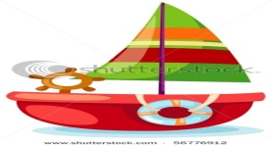
Doll
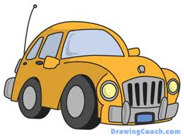
Car
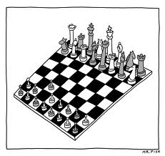
Boat

chess

Draw a Triangle

Complete writing letters
A ، ……،.C ،…..،E ،…….،G،…….،I ،……..،K ،…….. .
Counting the number and type

(……………..) (…………….) (………….) (………)

