Theme 4
Transportation the present and the future

Find the words:

Drive , cheap, fast, journey, ferry, helicopter, ride, subway, sail, fuel ,reliable, train, fly , bus , walk, ship, car, plane , tram, van, sea.

b | y | l | f | n | l | c | d | s | w
u | e | t | u | o | a | j | r | e | a
s | a | r | e | r | o | v | i | a | l
f | r | a | l | u | a | f | v | s | k
e | i | i | r | n | p | a | e | h | c
r | d | n | l | i | a | s | m | i | t
r | e | n | a | l | p | t | i | p | r
y | k | o | y | a | w | b | u | s | a
e | l | b | a | i | l | e | r | o | m
r | e | t | p | o | c | i | l | e | h

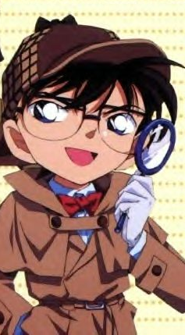
Good luck

