TRANPORTATION
Transport or transportation is the movement of people, animals and goods from one location to another. Modes of transport include air, rail, road, water, cable, pipeline, and space. The field can be divided into infrastructure, vehicles, and operations. Transport is important since it enables trade between peoples, which in turn establishes civilizations.
Transport infrastructure consists of the fixed installations necessary for transport, and may by roads, railways, airways, waterways, canals and pipelines, and terminals such as airports, railway stations, bus stations, warehouses, trucking terminals, refueling depots (including fueling docks and fuel stations), and seaports. Terminals may be used both for interchange of passengers and cargo and for maintenance.
Vehicles traveling on these networks may include automobiles, bicycles, buses, trains, trucks ,people, helicopters, and aircraft. Operations deal with the way the vehicles are operated, and the procedures set for this purpose including financing, legalities and policies. In the transport industry, operations and ownership of infrastructure can be either public or private, depending on the country and mode
Air
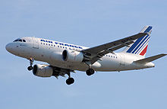 Land
Sea 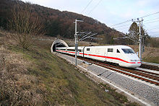
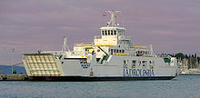
TRANSPORTATION IN THE PAST
Land
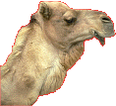
Camels
In 1860 the first camels arrived in Australia. These camels were used by our early explorers. For example, Burke and Wills took twenty-six camels on their ill-fated expedition across the continent. A man by the name of Thomas Elder recognized the value of the camel as a means of transport. Camels could be used to carry goods and people, especially in dry areas. In 1866, Sir Thomas Elder had imported one hundred and twenty camels from Karachi and established a camel breeding station in South Australia.
Air
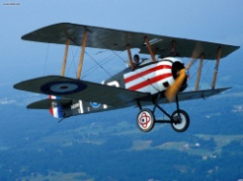 Aircraft
The aircraft used in this early service was an Armstrong Whitworth FK8 biplane. It was almost nine meters from tip to tail and would fit comfortably into the cargo hole of today's jumbo jets. During summer, the service took two days in each direction. The aircraft was built for the cooler English climate and could not operate in the heat of a Queensland summer day. Flights departed early in the morning from Charleville and reached Longreach by 11.00 a.m., then waited until the following day to fly to Cloncurry.
TRANSPORTATION IN THE PRESENT
LAND
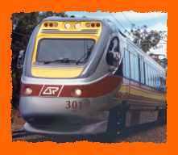 Rail

Rail services in Queensland are provided by Queensland Rail. Some of their passenger services include the Tilt Trains between the Brisbane-Bundaberg-Rockhampton corridor, the Kuranda Scenic Railway, long distance trains such as the 'Spirit of the Tropics', 'The Westlander' and 'The Sunlander' as well as the Citytrain network.
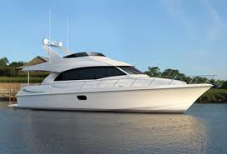 yacht
A yacht is a recreational boat or ship. The term originated from the Dutch Jacht meaning "hunt". It was originally defined as a light fast sailing vessel used by the Dutch navy to pursue pirates and other transgressors around and into the shallow waters of the Low Countries. After its selection by Charles II of England as the vessel of choice to return to Britain from Holland for his restoration, it came to be used to mean a vessel used to convey important persons.

