1
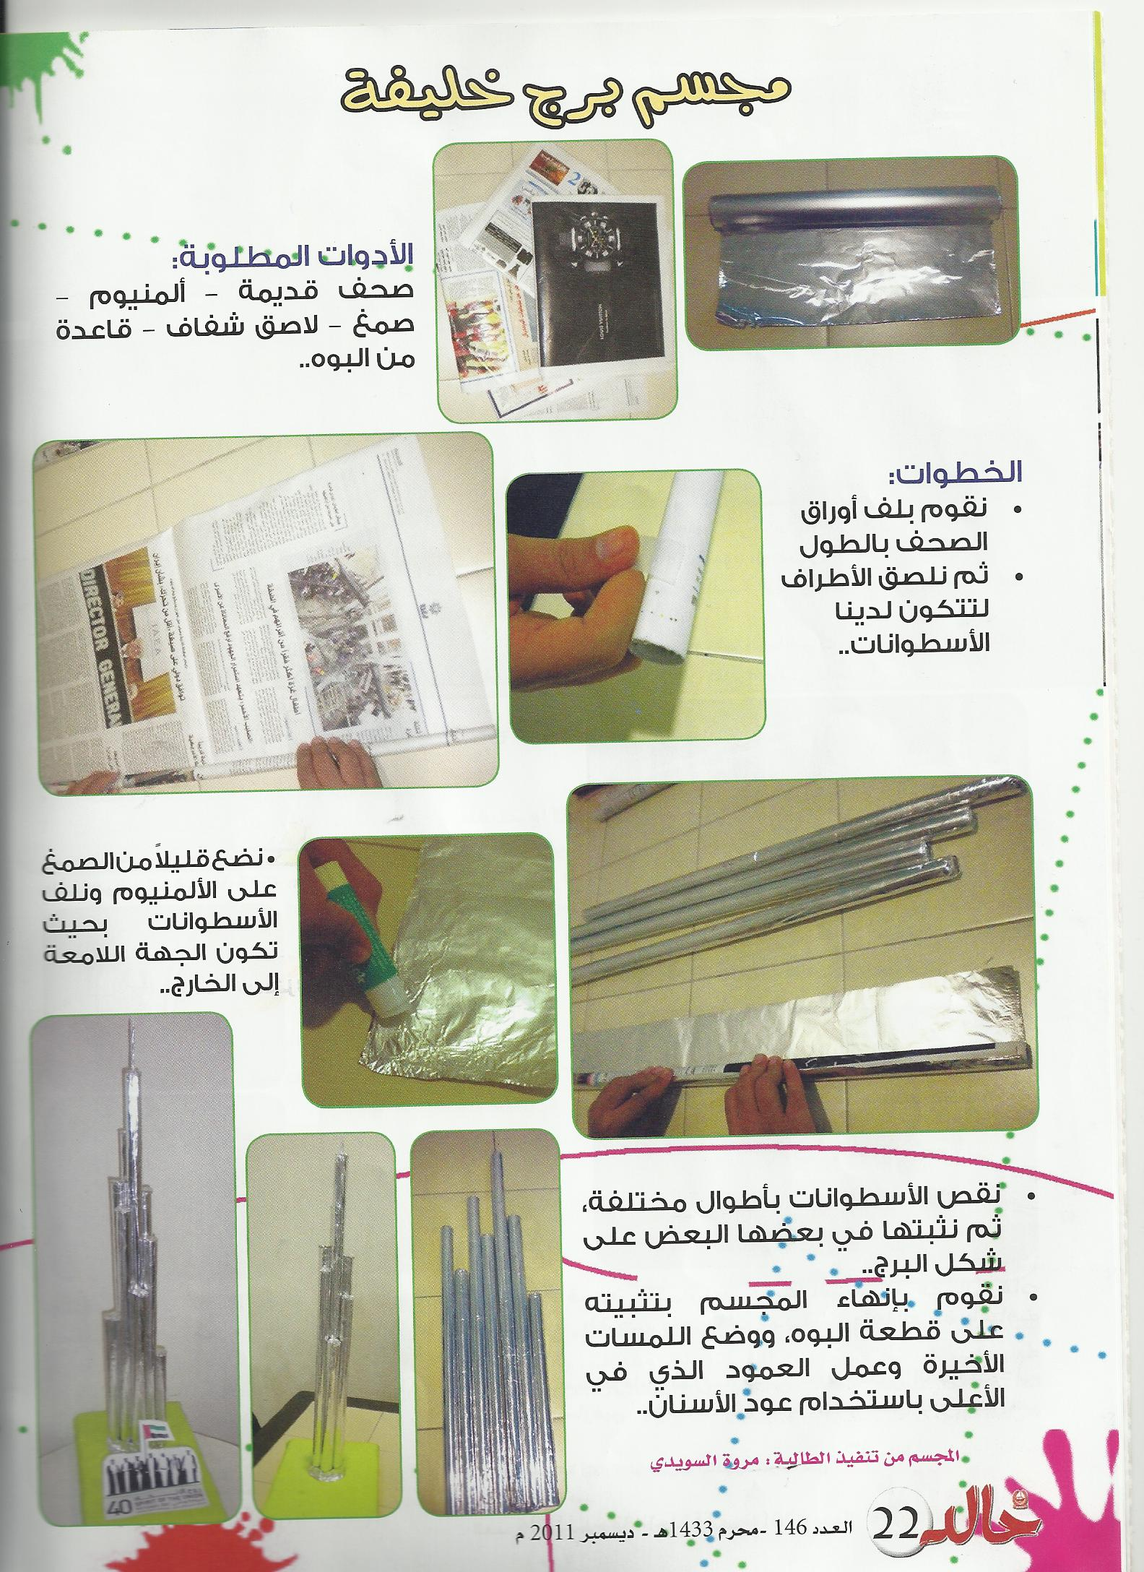
Tools required:
Old newspapers - Aluminum - glue - Scotch tape-The base of the Alboh

2
Steps: * We wrap the leaves lengthwise newspapers
* Then Nlsaf parties to form our cylinders

3
Put a little bit of glue and run a cylinder so that the
So that the shiny side to the outside

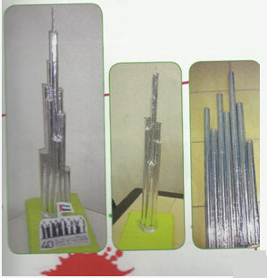
4

Lack of cylinders of different lengths, and then install it Each other In the form of tower..
We end on a piece of stereo install Alboh And finalize the work and the column at the top by Using a toothpick

*Project model of Burj Dubai
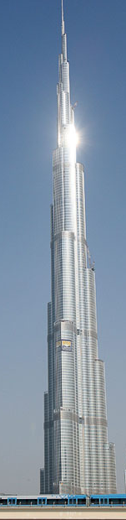
*Team work :
1- Ismail sobhi
2- Ahmad muftah
3- saif hemdan
4- Rashed Ali

*Class : ten \2

For English Subject.

Teacher : muhamed Riyad

