How to make a (lgaimat)?

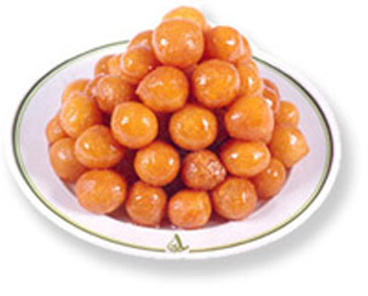
Intro: How to make really good lgaimat, nothing tastes on a chilly day than lgaimat traditional food of UAE.

Meterials: 1. Cup water 2. Spoon yeast
3. a pinch of salt 4. One egg
5. and a half cup flour
Instructions: 1. Mix warm water, yeast, flour and salt well.
2. Cover the pot and leave it in warm place for two hours or more.
3. Mix the egg with the dough leave it for 10 min, then come to the oil temperature of oil during frying task.
4. Finally, make on your hand from dough like the ball and put it in the oil, also do not put the bit behind each other so as not burn.
Name: Ibraheem AlAli

