Grade: 10 Chemistry worksheet(5), LC4 Ch7
Name: ------------------------------------ Section: ------------ ID: --------------------
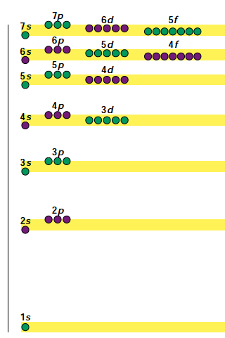
_____________________________________________________________________________________

- Refer to the above diagram to answer the coming questions:

1. Which orbital will be filled first with electrons: 1s

2. The orbital can maximum hold 2 electrons
3. As moving up through the level the energy increases or decreases? increases
4. How many electrons are required to fill completely all the 4p orbitals? 6
5. Which orbitals are higher in energy, 6s or 5d? 5d
6. Which sublevel is filled with electrons first 6s or 5d? Explain your answer.
6s is filled first because it has lower energy than 5d

- Match:

__c__1. Electron configuration a. s, p, d, or f within an energy level

_d___2. Inner transition element b. can hold a maximum of 2e⁻
__b__3. Orbital c. 1s² 2s² 2p⁶ 3s² 3p⁶

__a__4. Sublevel d. lanthanide or actinide

- Conceptual Questions:
- How is the light given off by fireworks similar to an element’s emission spectrum? Electrons gain energy and move to higher level. Then, they lose energy in form of light and go back to lower energy levels

- Define electron configuration.

the most stable arrangement of electrons in sublevels and orbitals

- How can the position of an atom in the periodic table be related to its electron configuration?
Period= the number of the highest energy level filled.
Group= the number of valence electron in the last filled energy level

