Grade: 10 Chemistry worksheet(2) LC4 Chapter 6, Sec 6.2 Name: ------------------------ Section: ------------ ID: ------------------
___________________________________________________________
I- Multiple Choice

- Circle the letter that is true about catalyst

 | A. | A catalyst is used up (consumed) in the chemical reaction
 | B. | A catalyst adds heat to the chemical reaction
 | C. | A catalyst speeds up a chemical reaction
 | D. | A catalyst can inhibit the chemical reaction

2. in an endothermic reaction, adding heat will _______ the reaction rate
 | A. | Speed up
 | B. | Slows down
 | C. | Not change
 | D. | facilitate

3. Lightning striking water (H₂O) to create hydrogen gas (H₂) and oxygen gas (O₂) is an example of _______
 | A. | synthesis
 | B. | decomposition
 | C. | Single displacement
 | D. | Double displacement

4. How can you slow down a chemical reaction?
 | A. | Add an inhibitor
 | B. | Add a catalyst
 | C. | Add more reactants
 | D. | Decrease the activation energy

5. In a chemical reaction, a hydrocarbon compound reacts with the diatomic element oxygen. What type of reaction is this?
 | A. | synthesis
 | B. | Double displacement
 | C. | Single displacement
 | D. | combustion

6. When iron nail is placed in water to rust. What type of chemical reaction is this?
 | A. | combustion
 | B. | Single displacement
 | C. | synthesis
 | D. | Double displacement

7. In combustion reaction of hydrocarbons, _______ must occur as a reactant.
 | A. | Carbon monoxide
 | B. | Oxygen gas
 | C. | Carbon dioxide
 | D. | Hydrogen gas

8. The _______ reaction is the opposite of synthesis reaction
 | A. | combustion
 | B. | decomposition
 | C. | Single displacement
 | D. | Double displacement

II- Use the diagram to answer the questions that follow.
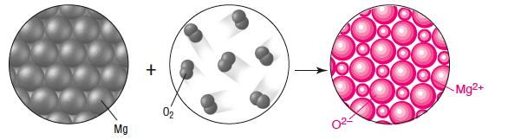
- Reactants name: magnesium and oxygen
- Reactants number: 2
- Products name: magnesium oxide
- Products number: 1
- Type of chemical reaction: synthesis

III- For the chemical reaction described by the equation below, suggest three ways to make the reaction shifts forward or back word.

N₂O₄ (g) + heat ⇔ 2NO₂(g)
- Forward shift:
a. add more N₂O₄
b. increase the heat
c. remove the NO₂

- Backward shift:
a. decrease the concentration of N₂O₄
b. decrease the heat
c. increase the concentration of the NO₂

IV) List and describe four factors that affect reaction rate.
- Temperature: in general, as temperature increases, rate increases
- Concentration of reactants: as concentration increases, rate increases
- Surface area: as surface increases, rate increases
- Catalyst: using a catalyst speeds up the reaction

