NAME ________________________ DATE _______________
PERIOD ______________________ CLASS ______________

10.6:Secants, Tangents, and Angle Measures-Part(1)
Q1] Find each measure. Assume that segment that appear to be tangent are tangent.
- m∠1
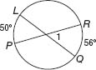
- m∠2
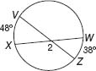
- m∠3
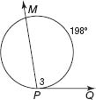
- m∠4
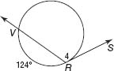
- m∠5
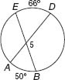
- m∠6
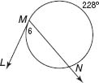
- m∠R
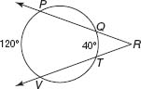
- m∠K
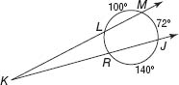
- m∠U
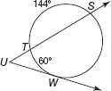
- m∠S
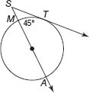
- 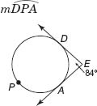
- 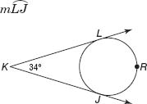

NAME ________________________ DATE _______________
PERIOD ______________________ CLASS ______________
10.6:Secants, Tangents, and Angle Measures-Part(2)
Q1] Find each measure. Assume that any segments that appear to be tangent are tangent.
- m∠1
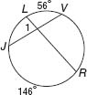
- m∠2
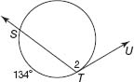
- m∠3
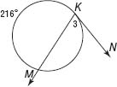
- m∠R
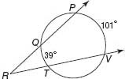
- 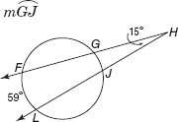
- m∠R
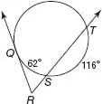
- m∠Y
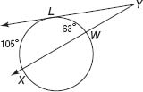
- 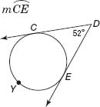
- 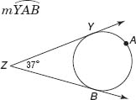
Q2] RECREATION In a game of kickball, Rickie has to kick the ball through a semicircular goal to score. If and the , at what angle must Rickie kick the ball to score? Explain.
