NAME ________________________ DATE _______________
PERIOD ______________________ CLASS ______________

10.1:Circles and Circumference- Part(1)
Q1]For Exercises 1- 7, refer to .
- Name the circle.  - Name a radius.  - Name a chord.  - Name a diameter.  - Name a radius not drawn as part of a diameter.  - Suppose the diameter of the circle is 16 centimeters. Find the radius.  - If PC = 11 inches, find AB. | 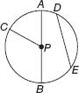

Q2] The diameters of and are 5 and 6 units, respectively. Find each measure.
- BF  - AB | 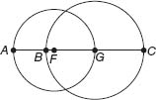

Q3] Find the diameter and radius of a circle with the given circumference. Round to the nearest hundredth.
- C = 36 m

- C = 17.2 ft

- C = 81.3 cm

- C = 5 yd

Q4] Find the exact circumference of each circle.
- 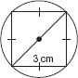
- 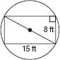

NAME ________________________ DATE _______________
PERIOD ______________________ CLASS ______________

10.1:Circles and Circumference- Part(2)
Q1] For Exercises 1-7, refer to .
- Name the circle.  - Name a radius.  - Name a chord.  - Name a diameter.  - Name a radius not drawn as part of a diameter.  - Suppose the radius of the circle is 3.5 yards. Find the diameter.  - If RT = 19 meters, find LW. | 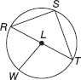

Q2] The diameters of and are 20 and 13 units, respectively, and QR = 4. Find each measure.
- LQ  - RM | 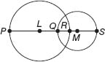

Q3] Find the diameter and radius of a circle with the given circumference. Round to the nearest hundredth.
- C = 21.2 ft
- C = 5.9 m

Q4] Find the exact circumference of each circle using the given inscribed or circumscribed polygon.
- 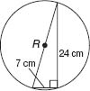
- 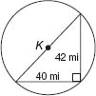
Q5] SUNDIALS Herman purchased a sundial to use as the centerpiece for a garden. The diameter of the sundial is 9.5 inches.
  - Find the radius of the sundial.
  - Find the circumference of the sundial to the nearest hundredth.

