NAME ________________________ DATE _______________
PERIOD ______________________ CLASS ______________

10.2:Measuring Angles and Arcs-Part(1)
1]and are diameters of . Identify each arc as a major arc, minor arc, or semicircle of the circle. Then find its measure.
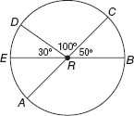
and are diameters of . Find each measure.
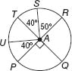

Use to find the length of each arc. Round to the nearest hundredth.
- if the radius is 5 inches  - if the diameter is 3 yards  - if JD = 7 centimeters  - if NL = 12 feet  - if DM = 9 millimeters  - if KD = 15 inches | 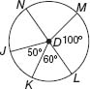

NAME ________________________ DATE _______________
PERIOD ______________________ CLASS ______________

10.2:Measuring Angles and Arcs-Part(2)
and are diameters of . Identify each arc as a major arc, minor arc, or semicircle of the circle. Then find its measure.
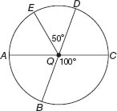
and are diameters of . Find each measure.
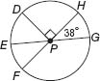
Use to find each arc length. Round to the nearest hundredth.
- , if QZ = 10 inches  - , if PZ = 12 feet  - , if TR = 15 meters  - , if ZQ = 7 centimeters | 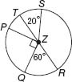

- HOMEWORK Refer to the table, which shows the number of hours students at Leland High School say they spend on homework each night.  - If you were to construct a circle graph of the data, how many degrees would be allotted to each category?  - Describe the arcs associated with each category.
  Homework
  Less than 1 hour | 8%
  1-2 hours | 29%
  2-3 hours | 58%
  3-4 hours | 3%
  Over 4 hours | 2%

