NAME ________________________ DATE _______________
PERIOD ______________________ CLASS ______________

10.3:Arcs and Chords-Part(1)
Q1] ALGEBRA Find the value of x in each circle.
- 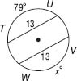
- 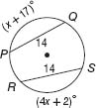
- 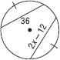
- 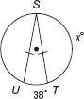
- 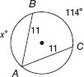
- 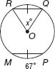
Q2] In the radius is 34, AB = 60, and . Find each measure. Round to the nearest hundredth.
- AD  - BD  - YD  - DC | 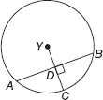
Q3] In , VW = 20 and YZ = 5x. What is x?
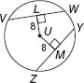
Q4] In , SZ = x + 4, and UZ = 2x − 1. What is x?
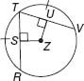

NAME ________________________ DATE _______________
PERIOD ______________________ CLASS ______________

10.3:Arcs and Chords-Part(2)
Q1] ALGEBRA Find the value of x in each circle.
- 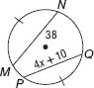
- 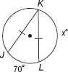
- 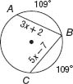
- 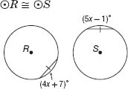
Q2] The radius of is 18, NK = 9, and . Find each measure.
- m∠HNE  - m∠HEN  - HN | 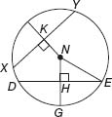
Q3] In , QR = 7x − 20 and TS = 3x. What is x?
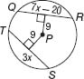
Q4] In , KN = 3x − 2, and KP = 2x + 1. What is x?
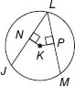
Q5] GARDEN PATHS A circular garden has paths around its edge that are identified by the given arc measures. It also has four straight paths, identified by segments and , that cut through the garden's interior. Which two straight paths have the same length?
