10 Chemistry worksheet(6) LC4 CH7
Name: ------------------------------------ Section: ------------ ID: -----------
I- Multiple Choice
- When an electron move from a higher level to a lower one ______

 | A. | Energy is absorbed
 | B. | Light is absorbed
 | C. | Light is emitted
 | D. | Nothing happens

2. An orbital can maximum holds _______
 | A. | 2 electrons
 | B. | 4 electrons
 | C. | 6 electrons
 | D. | 8 electrons

3. The third energy level contains ____ sublevels
 | A. | 2
 | B. | 3
 | C. | 4
 | D. | 5

4. The total number of electrons found in s and p sublevels is
 | A. | 2
 | B. | 6
 | C. | 8
 | D. | 10

5. The light emitted by the gas in a neon sign is ______________
 | A. | An electron
 | B. | An emission spectrum
 | C. | A filament
 | D. | An incandescent light

6. The combined ___________ sublevels have maximum18 electrons
 | A. | d and f
 | B. | p and d
 | C. | s, p, and d
 | D. | s, p, d, and f

7. What element has the electron configuration 1s²2s²2p⁶3s² 3P³?
 | A. | The element is in group 18
 | B. | The element is in group 2
 | C. | The element is in group 5
 | D. | The element is in group 3

8. An electron in an atom emits energy in the form of light when it ________
 | A. | Leaves the atom
 | B. | Rises to a new energy level
 | C. | Leaves the nucleus
 | D. | jumps to a lower energy level

9. Which of these is the electron configuration of an atom most likely to lose an electron?
 | A. | 1s² 2s² 2p⁶
 | B. | 1s² 2s² 2p⁶ 3s² 3p⁵
 | C. | 1s² 2s² 2p⁵
 | D. | 1s² 2s² 2p⁶ 3s² 3p⁶ 4s¹

10. Energy sublevels are designated ________
 | A. | 1, 2, 3, and 4
 | B. | a, b, c, and d
 | C. | s, p, d, and f
 | D. | x, y, and z

II- Use the diagram below to answer the questions that follow

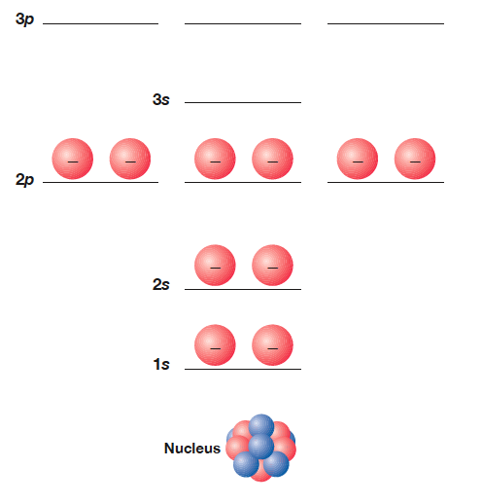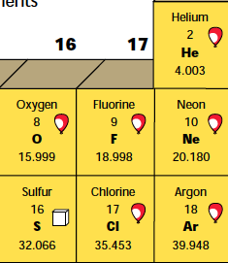
1. Find the valance electron: 8

2. Find the period: 2

3. Find the group: 8

4. Which atom is represented above? Neon, Ne

III Identify to which block the following electronic configurations belong:

Electron configuration | s block/ p block/ d block/ f block
4s² 3d² | d
2s² 2p⁶ | P
4s¹ 3d⁵ | d

