Princess Diana Detailed Biographry

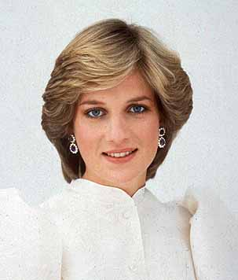

Diana, Princess of Wales, formerly Lady Diana Frances Spencer, was born on 1 July 1961 at Park House near Sandringham, Norfolk. She was the youngest daughter of the then Viscount and Viscountess Althorp, now the late (8th) Earl Spencer and the Hon. Lady Diana was educated first at a preparatory school, Riddlesworth Hall at Diss, Norfolk, and then in 1974 went as a boarder to West Heath, near Sevenoaks, Kent. At school she showed a particular talent for music (as an accomplished pianist), dancing and domestic science, and gained the school's award for the girl giving maximum help to the school and her schoolfellows. She left West Heath in 1977 and went to finishing school at the Institut Alpin Videmanette in Rougemont, Switzerland, which she left after the Easter term of 1978. The following year she moved to a flat in Coleherne Court, London. For a while she looked after the child of an American couple, and she worked as a kindergarten teacher at the Young England School in Pimlico.
Her romance with the Prince of Wales began in 1980 and they got married July 29, 1981 at St Paul's Cathedral. The wedding was broadcast in 74 countries and watched by 750 million people worldwide. Diana was the first English woman to marry an heir to the throne in over 300 years. But Diana soon discovered that Prince Charles was still in love with an old girlfriend, Camilla Parker-Bowles. Distraught, Diana developed bulimia and attempted suicide. Despite her problems, she was a devoted mother to her two sons, Prince William and Prince Harry. She worked tirelessly for charity, and was beloved by the public for her warmth and humanity.

In 1992 Princess Diana decided to expose the truth about her relationship with Prince Charles to the public. The separation of the Prince and Princess of Wales was announced on December 9, 1992. The divorce became official August 28, 1996. Princess Diana kept the title Princess of Wales and continued to work for her favorite charities. She and Prince Charles had joint custody of their sons. In 1997 Princess Diana began a love affair with Emad "Dodi" Fayed, the son of billionaire businessman Mohamed Al-Fayed. Their romance ended abruptly on August 31, 1997 when both were killed in a car accident in Paris while fleeing from paparazzi. Princess Diana's sudden death led to an unprecedented worldwide outpouring of grief and love.
Although the Princess was renowned for her style and was closely associated with the fashion world, patronising and raising the profile of younger British designers, she was best known for her charitable work. During her marriage, the Princess was president or patron of over 100 charities. The Princess did much to publicise work on behalf of homeless and also disabled people, children and people with HIV/Aids. The Princess remained as patron of Centrepoint (homeless charity), English National Ballet, Leprosy Mission and National Aids Trust, and as President of the Hospital for Sick Children, Great Ormond Street and of the Royal Marsden Hospital. In the year before her death, the Princess was an active campaigner for a ban on the manufacture and use of land mines. In January 1997, she visited Angola as part of her campaign. in June, the Princess spoke at the landmines conference at the Royal Geographical Society in London, and this was followed by a visit to Washington DC in the United States on 17/18 June to promote the American Red Cross landmines campaign (separately, she also met Mother Teresa in The Bronx

Hope you like it

Name : Raneem Esam
Class : Eight-5

