Healthy fruit
Orange
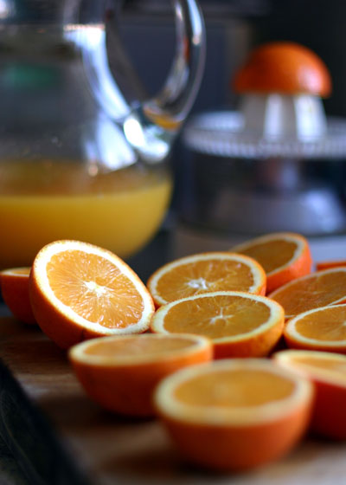
Orange has 80% of its weight of water and about 2% fat and about 10% and 5% fiber materials, metal
And acids, and about 3% of sugars and vitamin, it contains glucose, phosphorus and vitamin
B2-b1, niacin and vitamin C.
Benefits:
- Of an orange after food helps digestion.
- Rich in vitamin C help to stabilize the calcium in food.
- Tonic for the blood circulation and strengthens the liver.
- Benefit people with neurological diseases and those with diabetes or liver disorders, or infectious.

Grabes
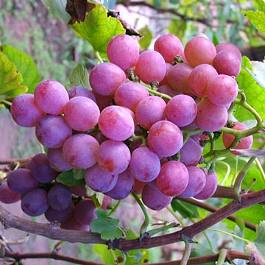
Contain cent grams of grapes on 75% of its weight of water and 7 grams glucose and fat grams and 16 grams
Carbohydrate and a half grams of protein and twenty milligrams of vitamin C and the best types of grapes large And white color.
Benefits:
- tonic for the muscles and nerves, and remade for the cells of toxins and repellent.
- fast food digestion.
- is useful in cases of poor digestion and the arrest and hemorrhoids and pebble pebble urinary and liver.
- a powerful tonic for liver function.
- grape rind of materials useful in cleaning the bowel.
- According to grapes in the prevention of cancer.
- for people with thin useful in weight gain
Strawberry
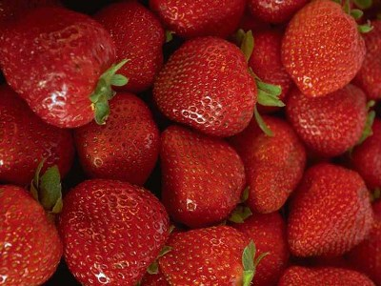

The fruit very elegance, luxury and beauty that hardly appear on the market until they disappear. What distinguishes the most important
Rich in sugar, mineral salts, especially calcium, phosphorus, iron, and no protein in the particle
Small, and contains a natural acid Alseisselat.
Benefits:
- Prescribed for patients with gout and liver lesions.
- Useful for gum disease.
- Strawberry property mitigation quantities acid urine.
- Are soothing to the nerves, and a painkiller.
Mango
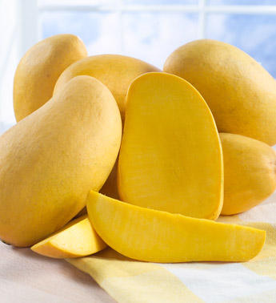
Mango fruit contains 20% sugar and 1% soluble protein and 1% fat and 1% of the organic acids
And 1% minerals and some vitamins are rich in fiber which is useful to stimulate a bowel movement and the prevention of some
Chronic diseases and is rich in vitamin A and c.
Benefits:
- helps growth.
- protect against cancer.
- keeps the gums.
- manga laxative syrup of the digestive tract
Name : Raneem Esam

