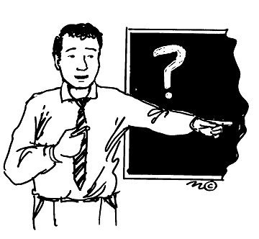
The teacher
In education , a teacher is a person who provides schooling for pupils and students.
These are some information about the teacher’s job :
Personal qualities and abilities :
Teachers need to know how to deal with students , how to understand their ideas and problems , how to persuade them and they must have the ability to teach students at different learning levels .The teacher must to be smart , kind , active , brave , patient , helpful , cooperator, punctual and honest .
Qualifications :

Teachers will need to possess a Bachelor's Degree in Education as a minimum qualification and/or a Subject related Degree with a Diploma in Education.
Working hours :
Most schools start earlier than the beginning time of the school day . Typically, the school day begins at 07:30 or 08:00 for students, and the finish time at 14:30 or 15:00, with an hour or so for lunch. The working week is from Sunday to Thursday.
Work place :
Most teachers work at schools , universities , colleges , institutes or other place of formal education . Some teachers Give private lessons to some students .
Experience :
Employers look for people who have the work skills like :
Excellent planning and organizational skills; ability to put together lesson plans and prepare required materials for classes of different skills and year groups.
Salary :
Salary range for classroom teachers is 1000-6000 dhs per month for most government schools and 1000-20,000 dhs per month for private schools.

