Rainforest
From Wikipedia, the free encyclopedia
For other uses, see Rainforest (disambiguation).

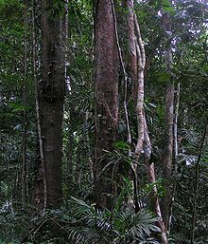
The Daintree Rainforest in Queensland,Australia.

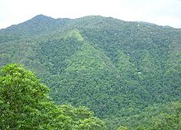
The Daintree Rainforest near Cairns, inQueensland, Australia.

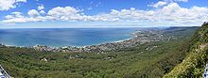
Part of the Illawarra Brush, in New South Wales, Australia.
Rainforests are forests characterized by high rainfall, with definitions setting minimum normal annual rainfall between 1750–2000 mm (68-78 inches). The monsoon trough, alternately known as the intertropical convergence zone, plays a significant role in creating Earth's tropical rain forests.
A total of 40 to 75% of all species on the world's habitats are indigenous to the rainforests.^{[1]} It has been estimated that many millions of species of plants, insects, and microorganisms are still undiscovered. Tropical rainforests have been called the "jewels of the Earth", and the "world's largest pharmacy", because over one quarter of natural medicines have been discovered there.^{[2]}Rainforests are also responsible for 28% of the world's oxygen turn over, often misunderstood as oxygen production,^{[3]} processing it through photosynthesis from carbon dioxide and storing it ascarbon through biosequestration.
The undergrowth in a rainforest is restricted in many areas by the lack of sunlight at ground level. This makes it possible to walk through the forest. If the leaf canopy is destroyed or thinned, the ground beneath is soon colonized by a dense, tangled growth of vines, shrubs, and small treescalled a jungle. There are two types of rainforest, tropical rainforest and temperate rainforest.

Contents
[hide]
- 1 Tropical
- 2 Temperate
- 3 Layers
  - 3.1 Emergent layer
  - 3.2 Canopy layer
  - 3.3 Understory layer
  - 3.4 Forest floor
- 4 Flora and fauna
- 5 Soils
- 6 Effect on global climate
- 7 Human uses
- 8 Native peoples
- 9 Deforestation
- 10 See also
- 11 References
  - 11.1 Further reading
- 12 External links

Tropical
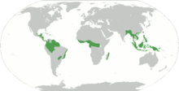
General distribution of tropical rainforest
Main article: Tropical rainforest
Many of the world's rainforests are associated with the location of the monsoon trough, also known as the intertropical convergence zone.^{[4]} Tropical rainforests are rainforests in the tropics, found near the jamaica (between the Tropic of Cancer and Tropic of Capricorn) and present in Southeast Asia (Myanmar to Philippines, Indonesia, Papua New Guinea, and northeastern Australia), Sri Lanka, Sub-Saharan Africa from Cameroon to the Congo (Congo Rainforest), South America (e.g. the Amazon Rainforest), Central America (e.g. Bosawás, southern Yucatán Peninsula-El Peten-Belize-Calakmul), and on many of the Pacific Islands (such as Hawaiʻi). Tropical rainforests have been called the "Earth's lungs," although it is now known that rainforests contribute little netoxygen additions to the atmosphere through photosynthesis.^{[5][6]}

Temperate
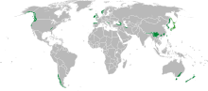
General distribution of temperate rainforest.
Main article: Temperate rainforest
Temperate rainforests are rainforests in temperate regions. They can be found in North America(in the Pacific Northwest, the British Columbia Coast, and in the inland rainforest of the Rocky Mountain Trench east of Prince George), in Europe (parts of the British Isles such as the coastal areas of Ireland, Scotland, southern Norway, parts of the western Balkans along the Adriaticcoast, as well as in the North West of Spain and coastal areas of the eastern Black Sea, includingGeorgia and coastal Turkey), in East Asia (in southern China, Taiwan, much of Japan and Korea, and on Sakhalin Island and the adjacent Russian Far East coast), in South America (southernChile) and also Australia and New Zealand.

Layers
A tropical rainforest is typically divided into four main layers, each with different plants and animals adapted for life in that particular area: the emergent, canopy, understory, and forest floor layers.

Emergent layer
The emergent layer contains a small number of very large trees called emergents, which grow above the general canopy, reaching heights of 45–55 m, although on occasion a few species will grow to 70–80 m tall.^{[7][8]} They need to be able to withstand the hot temperatures and strong winds in some areas. Eagles, butterflies, bats, and certain monkeys inhabit this layer.
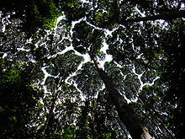
The canopy at the Forest Research Institute Malaysia

Canopy layer
Main article: Canopy (ecology)
The canopy layer contains the majority of the largest trees, typically 30–45 m tall. The densest areas of biodiversity are found in the forest canopy, a more or less continuous cover of foliage formed by adjacent treetops. The canopy, by some estimates, is home to 50 percent of all plant species, suggesting that perhaps half of all life on Earth could be found there. Epiphytic plantsattach to trunks and branches, and obtain water and minerals from rain and debris that collects on the supporting plants. The fauna is similar to that found in the emergent layer, but more diverse. A quarter of all insect species are believed to exist in the rainforest canopy. Scientists have long suspected the richness of the canopy as a habitat, but have only recently developed practical methods of exploring it. As long ago as 1917, naturalist William Beebe declared that "another continent of life remains to be discovered, not upon the Earth, but one to two hundred feet above it, extending over thousands of square miles." True exploration of this habitat only began in the 1980s, when scientists developed methods to reach the canopy, such as firing ropes into the trees using crossbows. Exploration of the canopy is still in its infancy, but other methods include the use of balloons and airships to float above the highest branches and the building of cranes and walkways planted on the forest floor. The science of accessing tropical forest canopy using airships, or similar aerial platforms, is called dendronautics.^{[9]}

Understory layer
Main article: Understory
The understory layer lies between the canopy and the forest floor. The understory (or understorey) is home to a number of birds, snakes, and lizards, as well as predators such as jaguars, boa constrictors, and leopards. The leaves are much larger at this level. Insect life is also abundant. Many seedlings that will grow to the canopy level are present in the understory. Only about 5% of the sunlight shining on the rainforest reaches the understory. This layer can also be called a shrub layer, although the shrub layer may also be considered a separate layer.

Forest floor
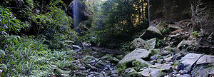
Rainforest in the Blue Mountains, Australia
The forest floor, the bottom-most layer, receives only 2% of sunlight. Only plantsadapted to low light can grow in this region. Away from riverbanks, swamps, and clearings where dense undergrowth is found, the forest floor is relatively clear of vegetation because of the low sunlight penetration. It also contains decaying plant and animal matter, which disappears quickly due to the warm, humid conditions promoting rapid decay. Many forms of fungi grow here which help decay the animal and plant waste.

Flora and fauna
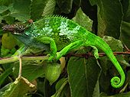
West Usambara Two-Horned Chameleon (Bradypodion fischeri) in the Usambara Mountains,Tanzania.
More than half of the world's species of plants and animals are found in the rainforest.^{[10]} Rainforests support a very broad array of fauna including mammals, reptiles, birds, and invertebrates. Mammals may include primates, felids, and other families. Reptiles include snakes, turtles, chameleons, and other families while birds include such families as vangidae and Cuculidae. Dozens of families of invertebrates are found in rainforests. Fungi are also very common in rainforest areas as they can feed on the decomposing remains of plant and animal life. These species are rapidly disappearing due to deforestation, habitat loss, and biochemical releases into the atmosphere.^{[11]}

Rainforests of the World
Wild and wondrous, rainforests extend from as far as Alaska and Canada to Latin America, Asia and Africa. They nurture thousands of plants and animals found nowhere else on Earth and provide life's essentials such as our medicines, food and water.
The Nature Conservancy is working around the world in places like Costa Rica's Osa Peninsula to protect rainforests, engaging local and indigenous communities in creative solutions that balance the needs of people with nature.
The places and projects featured on this site reflect examples of The Nature Conservancy's current work in rainforest protection. And every year, through our Adopt an Acre® program, we choose an imperiled rainforest site that is in critical need of protection.

