body | 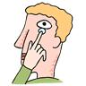
head | 
face | 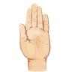
ear | 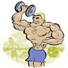
eye | 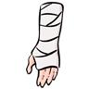
nose | 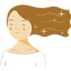
toe | 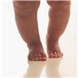
mouth | 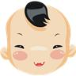
hair | 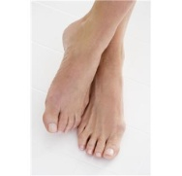
shoulder | 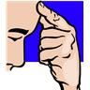
hand | 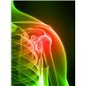
leg | 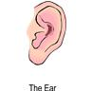
finger | 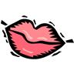
knee | 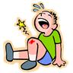
feet | 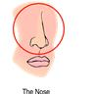
arm | 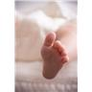

Little | 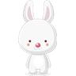
Big | 
Clown | 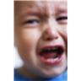
Happy | 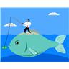
Mad | 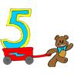
Sad | 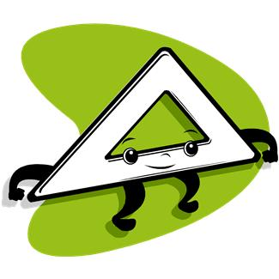
Five | 
triangle | 