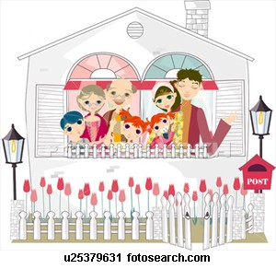
Done by:
Father
Mother
Grandfather
Grandmother
Brother
Sisters
FAMILY TREE

