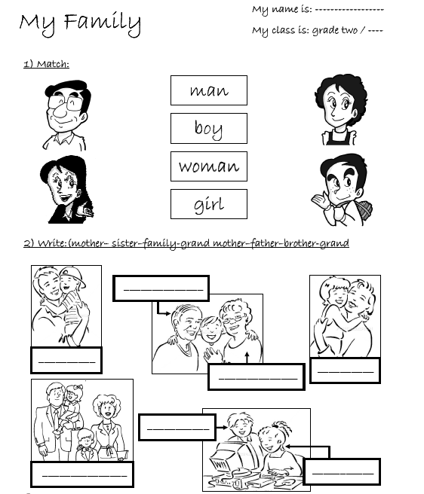

Done By : ……………………. Class/2nd-3 Teacher : …………………..

