Match the shapes with the correct number.
worksheet
 |  | 2
 |  | 3
 |  | 5
 |  | 1
 |  | 4
 |  | 8
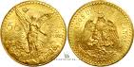  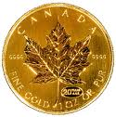  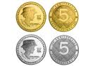 |  | 10
 |  | 9
 |  | 6
 |  | 7

Questions


How many?

= = = =

= =

