Abudhabi Education Council
Emirates College for Advanced Education
Final Exam

Final Exam

Student name:
Grade:
Section:
Mark:
Duration: 2 hours.
Mark: 10
Strand: life system. Bloom taxonomy: Knowledge. Indicator: identify and describe how characteristics of living things help them to interact with each other and with their environment. Content: Identify characteristics of plants that help them to grow and survive in their environment.
Question 1: Draw and label the parts of the plant.

Strand: life system. Bloom taxonomy: Knowledge. Indicator: identify and describe how characteristics of living things help them to interact with each other and with their environment. Content: Identify characteristics of plants that help them to grow and survive in their environment.

Question 2: Identify characteristics of plants that help them to grow?
Mark: 5
----------------------------------------------------------------------------------------------.
Strand: life system. Bloom taxonomy: Analysis. Indicator: identify and describe how characteristics of living things help them to interact with each other and with their environment. Content: identify characteristics of plants that help them to grow and survive in their environment.
Mark: 10
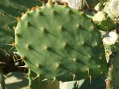
Question 3: Compare the features between water plant and desert plant.
1) -----------------------------
2) ----------------------------- Desert plant
3) -----------------------------
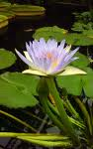
1) -----------------------------
2) ----------------------------- Water plant
3) -----------------------------
Strand: life system. Bloom taxonomy: Knowledge. Indicator: identify and describe how characteristics of living things help them to interact with each other and with their environment. Content: identify characteristics of animal that help them to interact and grow and survive in their environment.
Mark: 10
Question 4: Give 3 examples of animals or birds that live in each of these environments.
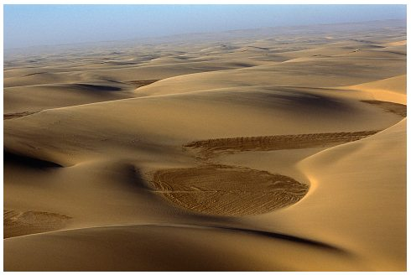  Desert | - --------------------------------  - --------------------------------  - --------------------------------
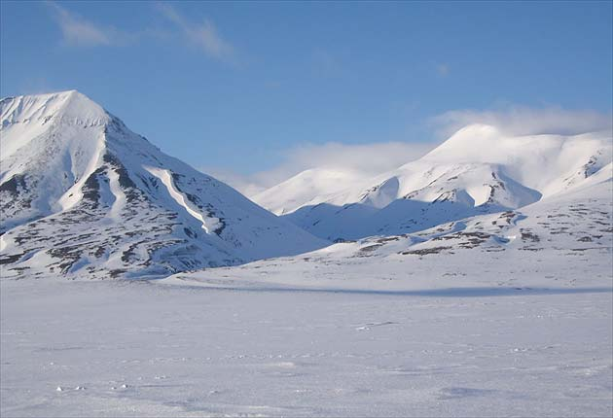  Arctic | - --------------------------------  - --------------------------------  - --------------------------------
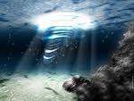  Sea | - --------------------------------  - --------------------------------  - --------------------------------
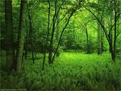  Jungle | - --------------------------------  - --------------------------------  - --------------------------------
Strand: Energy systems. Bloom taxonomy: Application. Indicator: identify forms of sources of energy, and ways in which energy causes change. Content: (see attached paper behind – energy system).

Question 5: Predict and Tick the correct box to show if a question is true or false
Mark: 12
T F
- Heat energy does not cause any changes in food?
- Heat energy can change a solid in to a liquid?
- When a solid changes to a liquid, this is called dissolving?
- A cooker/ oven is a source of heat energy?
- A freezer is a source of heat energy?
- When a liquid turns to a gas this is called evaporation
Strand: Energy systems. Bloom taxonomy: Analysis. Indicator: identify forms of sources of energy, and ways in which energy causes change. Content: (see attached paper behind – energy system).
Mark: 10
Question 6: Write the correct word for type of chemical change.
Analyze what change has taken place?

----------------------------------
 |  |  | ----------------------------------
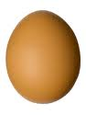 |  | 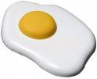 | ----------------------------------
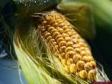 |  |  | ----------------------------------
Strand: Energy systems. Bloom taxonomy: Comprehension. Indicator: identify forms of sources of energy, and ways in which energy causes change. Content: (see attached paper behind – energy system).
Mark: 10
Question 7: Fill in the blank.

All the changes above are caused by -----------. The light bulb being turned on is caused by ------------ energy and all the other changes are caused by ----------- energy.

Strand: Energy systems. Bloom taxonomy: Synthesis. Indicator: identify forms of sources of energy, and ways in which energy causes change. Content: (see attached paper behind – energy system).

Question 8: Create and design the process of change of the liquid from solid to gas.
Mark: 10
.

(Evaluation)
)
-Justify how liquid changed to the evaporation?
------------------------------------------------------------------------------------------------------------

Question 9: Write the definition of the following words:
Mark: 5
Strand: Matter. Bloom taxonomy: Knowledge. Indicator: identify and describe changes that can be made to materials. Content: (see attached paper behind – Matter).
Question 9: Define the following words.
Melting: __________________________________________________________.

Dissolving: ________________________________________________________.

Evaporation: ________________________________________________________________.

Strand: Matter. Bloom taxonomy: Analysis. Indicator: identify and describe changes that can be made to materials. Content: (see attached paper behind – Matter).

Mark: 10
Grouping materials
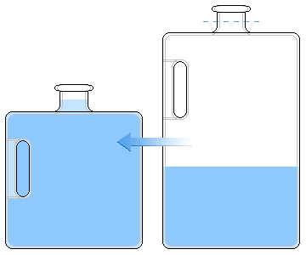
Question 10: What happens to the liquid when it is poured into different containers?

- ------------------------------------------------------------------------------------------------

- ------------------------------------------------------------------------------------------------

- ------------------------------------------------------------------------------------------------

Mark: 8
Strand: Matter. Bloom taxonomy: Comprehension. Indicator: identify and describe changes that can be made to materials. Content: (see attached paper behind – Matter).
Question 11: Choose the correct answer.
- I have definite shape and volume. What am I?
- Gas.
- Solid.
- Liquid.
- Matter.
- Oxygen.

- I can be squashed and still keep my shape. What am I?
- Gas.
- Solid.
- Liquid.
- Matter.
- Oxygen.

- I am the air you breathe. What am I?
- Gas.
- Solid.
- Liquid.
- Matter.
- Oxygen.

- I fill the space of my container and keep its shape. What am I?
- Gas.
- Solid.
- Liquid.
- Matter.
- Oxygen.
References:

"الرئيسية - تعلم لأجل الإمارات." الرئيسية - تعلم لأجل الإمارات. N.p., n.d. Web. 2 June 2010. <http://www.study4uae.com>.
Galien, Michael van der. "Right Across the Atlantic: Welcome!." Right Across the Atlantic: Welcome!. N.p., n.d. Web. 2 June 2010. <http://www.theatlanticright.com>.
"Hallett Cove South Primary School." Hallett Cove South Primary School. N.p., n.d. Web. 2 June 2010. <http://web.hcsps.sa.edu.au/>.
"MisterChucker.com - Nothing to see here...." MisterChucker.com - Nothing to see here.... N.p., n.d. Web. 2 June 2010. <http://www.misterchucker.com
Marjonnabar. "Webshots - Photo Sharing, Free Wallpaper and Free Screensavers." Webshots - Photo Sharing, Free Wallpaper and Free Screensavers. N.p., n.d. Web. 2 June 2010. <http://webshots.com/>.
"Welcome to Flickr - Photo Sharing." Welcome to Flickr - Photo Sharing. N.p., n.d. Web. 2 June 2010. <http://flickr.com/>.

