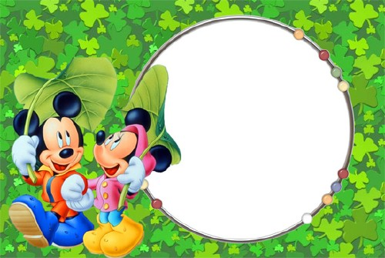
English Note Book
Grade 3 Part 2
Unite 7
The words | Meaning | The words | Meaning | The words | Meaning
Some  An – A  Beef Burger  Drinks  Juice  Cold  Hot  Please  Desserts  Ask  Like  Pot  Old  Do  Don’t  Chicken | بعض  واحد – واحدة  بورجر لحم  مشروبات  عصير  بارد  ساخن  من فضلك  حلويات  يسأل  يحب  قدر  قديم  يفعل  لا يفعل  دجاج | Potato  Food  Pudding  Soup  Eggs  Pizza  Pineapple  Grapes  Peas  Corn  Strawberries  Cake  Apple  Water melon  Bread  Menu | بطاطا  طعام  البودنج (نوع من الحلوى)  شوربة  بيض  بيتزا  أناناس  عنب  بازلاء  ذرة  فراولة  كيكة  تفاح  بطيخ  خبز  قائمة الطعام | Carrot  Cookies  Cheese  Lettuce  Tomato  Rice  Sandwich  New | جزر  كعك  جبنه  خس  طماطم  أرز  ساندويتش  جديد

UNITE (7)
FOODS
The vowel letters

A-E-I-O-U
There are five 5 Vowel Letters they are
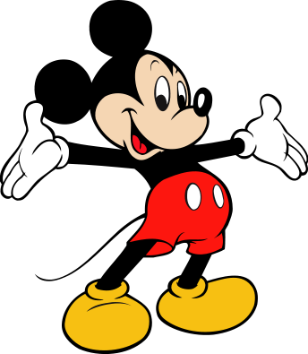

Some Indefinite articles
A An
Some

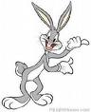

 | A
Used |  | Example
Is used with words that begin with a consonant letters |  | Book  Car  Dog
 | An
Used |  | Example
Is used with words that begin with a vowel letters |  | Apple  Elephant  Orange

 | Some
Used |  | Example
Is used with indefinite quantity |  | Some Apple  Some Orange

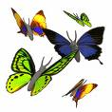
Exercise
Choose(an – a – some)
- Ahmed wants ………………….. rice
- I want to eat …………………… apple
- Do you want …………………… cookies?
- My mother wants ……………... tomatoes
- She wants to eat …… carrot and …… orange
Note
Positive answer
Do – Dose

He
She
It

I
You
We
They

Yes + + do Yes + +dose

Examples
- Do you like orange?
Yes, I do.
- Do they like milk?
Yes, they do.
- Dose he eat an apple?
Yes, he does.
Negative answer
Don’t – Doesn’t

He
She
It

I
You
We
They

Yes + + don’t Yes + +doesn’t

Examples
- Do you like to eat rice and chicken?
No, I don’t.
- Do they eat an apple?
No, they don’t.
- Does she work at night?
No, she doesn’t.
Have
Verb to have in present
Have
Has
- Form

Have | I
Have | We
Have | You
Have | They
- Have
Has | He
Has | She
Has | It

- Has

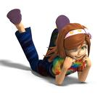
Examples
- I have a bag.
- He has a book.
- They have a computer.
- She has a camera.
- You have a car .
- We have a shop.
Exercise
- Choose( have – has )
- He ……………………….. a pencil.
- I ………………………... a big bag.
- They ……………………... a bus.
- We ……………………….. homework.
- My cat…………………… white hair.
- She ………………………. a baby.
- You ………………………. a red car.
Milk Strawberries
Eggs
Banana Orange
2.Fill in
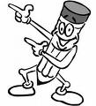

- Monkey like …………………………….
- Cows give us ……………………………
- Boys and girls like………………………
- They are red and small ………………...
- Hens give us …………………………….
- Choose the right words

1.Ahmed (want – wants – wanting ) some apples.
2. They are ( play – plays – playing ) football.
3. We ( drink – drinks – drinking ) milk.
4. Soha and Sara ( want – Wants – wanting ) pizza.
3. Circle the odd one out

Fish  Swing  Potato  Tomato | 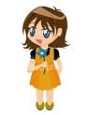 | Dinner  Lunch  Slide  Breakfast |  | Orange  Apples  Bananas  Sandwich

4.Write (Yes I do ) or ( No I don’t )
- Do you like orange juice? ………………………………………..
- Do you like cheese sandwiches? …………………………………
- Do you like chicken soup? ……………………………………….
- Do like cookies and milk? ………………………………………..

5. Classify the words

Fish Potatoes Milk Ice-Cream Rice Pizza Chicken Beef Burger Water Orange juice Cake Pudding

Main Courses | Drinks | Desserts

6.Write the word under the picture
A banana An apple A carrot
A tomato Some cheese Beef Burger

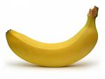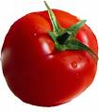
….…………………………………….. …………………………………
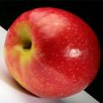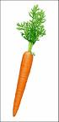
……………………………………………. ……………………………………
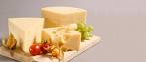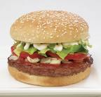
………………………………………………. …………………………………..
6.Choose ( a – an – some )

- I want ……………… apple.
- She likes …………… cheese.
- We eat ……………... fish.
- He wants …………… banana.
- You drink ………….. cup of milk.

7.Answer this question
What food do you want to make salad?

……………………………………………………………………….
……………………………………………………………………….
……………………………………………………………………….
……………………………………………………………………….

9.Circle the correct answer
- It’s time to ………….. breakfast. (drink – eat )
- What do you ………… to drink? (want – play )
- I want ………………... ice-cream , please. (a – some )
- I like orange ……………. (burger – juice )
- I can read the main course in the …………….. (menu – soup )
10.Answer the questions
Yes, I do – No, I don’t – Yes, he does – No, he doesn’t
- Do you like orange?
……………………………………………
- Do you like to eat rice and chicken?
……………………………………………
- Does he eat an apple?
……………………………………………
- Do you like milk?
……………………………………………
- Does he like pudding?
……………………………………………
11.Match the word to the picture
orange
Ice - cream
An apple
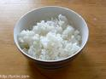 Sandwich
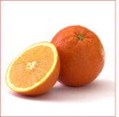 Cheese
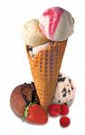 A beef burger
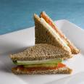 Rice
12.Classify the words
Banana Apple Carrot
Tomato Chicken Onion Strawberries

Fruit | Soup

13.Write the word under the picture
Potatoes - Rice - Cheese - Tomatoes - Chicken - Fish - Milk
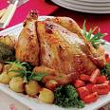 …………………………
…......................
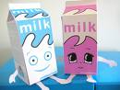 …………………………
…………………………
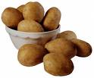 …………………………
…………………………
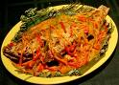 …………………………

14.Circle ( yes I do – No I don’t )
Do you want a sandwich?
Yes I do
No I don’t
Do you want some ice- cream?
Yes I do

No I don’t

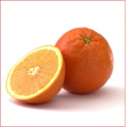 Do you want an orange?
Yes I do

No I don’t

Do you want a beef burger?
Yes I do

No I don’t

Do you want an apple?
Yes I do

No I don’t

Do you want a banana?
Yes I do

No I don’t

Do you want milk?
Yes I do

No I don’t

15.Re-order these sentences
- wants – Father – orange – an.
…………………………………………………………….
- wants – He – a – carrot.
…………………………………………………………….
- you – Do – want – sandwich – a ?
…………………………………………………………….
- Want – I – apple – an.
…………………………………………………………….
- bananas – I – like – oranges – and.
…………………………………………………………….
- some – apples – The – wants – boy.
……………………………………………………………
- has – a – sandwich – girl – The.
……………………………………………………………
- please – I – some – water – want.
……………………………………………………………
- do – you – What – to – want – drink?
……………………………………………………………
- fish – I – like.
…………………………………………………

16. Answer the questions
1. What do you eat in your breakfast?
……………………………………………………………………………….
……………………………………………………………………………….
……………………………………………………………………………….
……………………………………………………………………………….
2.What do you eat in your lunch?
……………………………………………………………………………….
……………………………………………………………………………….
……………………………………………………………………………….
……………………………………………………………………………….
3.what do you eat in your dinner?
………………………………………………………………………………..
………………………………………………………………………………..
………………………………………………………………………………..
………………………………………………………………………………..

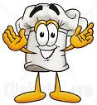

17. Choose ( a – an – some )
1. The bird wants ……………… apple.
2. the boy eats …………………. Egg.
3. Do you want ………………… water.
4. Can I have …………………... sandwich, please?
5. There are …………………….. tomatoes on the table.
6. My brother has ………………. Book.
7. I like to have …………………. Bird.
8.There is………………………… elephant in the zoo.
Lettuce
Bread
Apple
carrot
18.Fill in the food chart

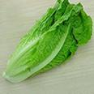
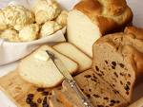
19. Match the word to the pictures
Cheese
Potatoes 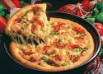
Juice
Fish
Milk
Pizza
Lettuce 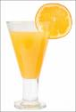
Sandwich
20. finish the sentence ( a – an – some )
1. Ali wants …………………………………… rice.
2. I want ………………………………………. Apple.
3. Do you want ………………………………... carrots?
4. Mona wants ………………………………… tomatoes.
5. Do you want ………………………………… oranges?
6. Mother wants ………………………………. Cookies. 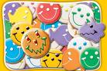
7. Do you want ………………………………… sandwich?
21. Complete the missing letter

P— tat--- --- s Ap --- les
Let --- uce Che --- se
S --- andw --- ch Piz --- a
Or --- nges Br --- ad
B --- nanas Ch --- cken
R --- ce M ---lk
F ---sh Co ---kies
T ---m ---to ---s Ju ---ce
C --- rr --- ts Me --- t

22. Read and answer
Cat likes fish. One day cat sees a fish in a bowl. It jumps and jumps , but it can’t touch the fish. It climbs on chair and jumps, but it can’t touch the fish. A dog comes in and asks, “do you want this fish ?” Cat says “no, not me” fish looks happy, but cat doesn’t.
Mark (√ ) or ( × )
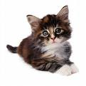

- Cat likes apple. (…………….)
- It climbs on a chair. (…………….)
- It sees a fish in a bowel. (…………….)
- It can touch the fish. (…………….)
- Cat looks happy. (…………….)
Answer these questions
- What dose cat like?
…………………………………………….
- What dose cat see in a bowl?
…………………………………………….
- Who asks “ do you want this fish ?”
…………………………………………….
- Where does it climb?
……………………………………………
- Who looks happy?
……………………………………………

Created By: Salama Mohammed Hussain Al Rashdi
Class : 3/E
School: Al Zafaranah
Subject: English

