Is | One  للمفرد | Now
Are | More than one  للجمع و المثنى | Now
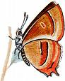
Using is and are


☼Write is or are to complete each sentence.
☺1- The books…………on my desk .
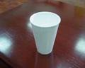
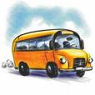
☺2- The cup ………..on the table. ☺3-The bus ………….big .
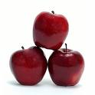
☺4- Sara and Ali ………in the park .
☺ 5- The apples …………red .
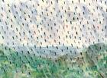
☺6- The sun…………bright .
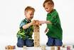
☺7- The sky ……….cloudy .
☺8- It ………raining .
☺9- The children ……….in-side the house .
☺10- Mom and dad ………..working .


Name……………………………………………………………………

