
7:00 ---------------------------------------------------
8:00 ---------------------------------------------------
9:00 ---------------------------------------------------
10:00 -------------------------------------------------
11:00 -------------------------------------------------




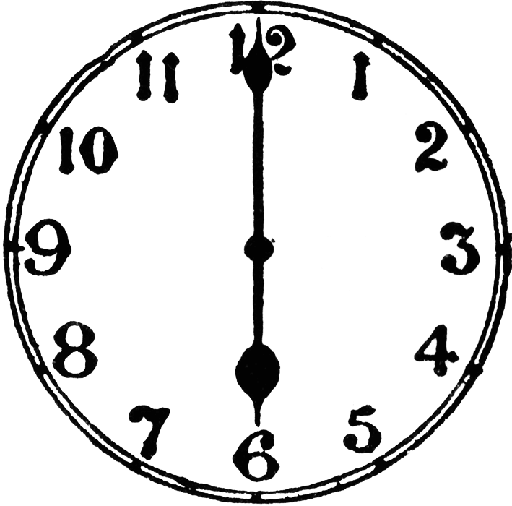
12:00 ---------------------------------------------------
1:00 ---------------------------------------------------
2:00 ---------------------------------------------------
3:00 -------------------------------------------------
4:00 -------------------------------------------------
5:00 --------------------------------------------------



6:00 ---------------------------------------------------
7:00 ---------------------------------------------------
8:00 ---------------------------------------------------
9:00 ---------------------------------------------------

