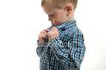
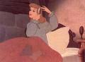
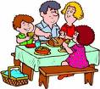
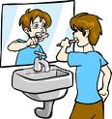
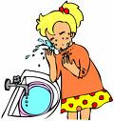
Read And Number :

1 - Ahmed brushes his teeth .
2 - Fatima gets up .
3 -Mira washs her face .
4 They eat dinner .
5 Salim gets dressed .
ــــــــــــــــــــــــــــــــــــــــــــــــــــــــــــــــــــــــــــــــــــــــــــــــــــــــــــ
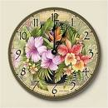
What Time Is It :
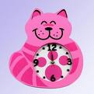
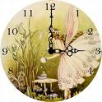
clock ۥO It's …………….……… clock ۥO It's ……………….………
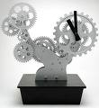
clock ۥ ………………………O It's clockۥO It's......................

