English Listening Test
- Match the picture to the correct word

Red Green Blue

Yellow Black Purple

Orange Pink White

Brown Grey

- Match

scissor
notebook
paper
picture
glue
door
window

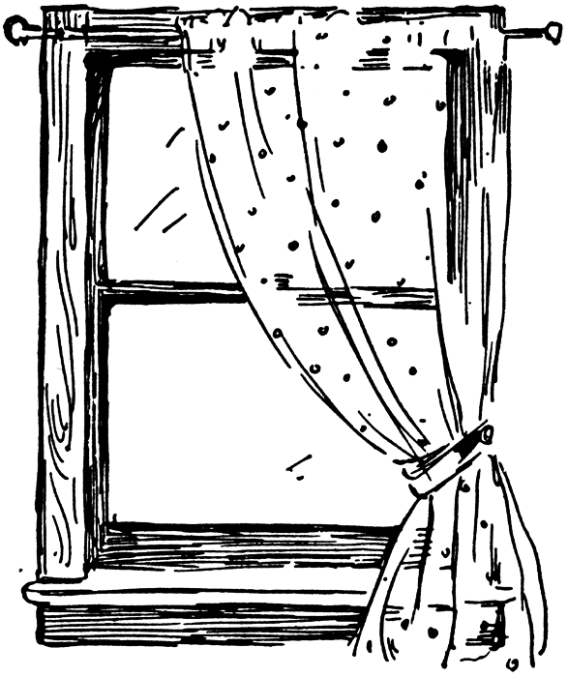






- Write.

feet mics children teeth

foot
mouse
tooth
children

- Write
singing writing reading coloring talking


- They are ……………… .


- She is ……………….. .


- He is …………. .


- They are …………. .

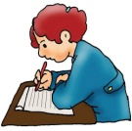
- She is …………. .

