Food chain

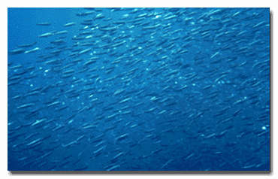
Seabirds and fish are just two parts of the Alaskan marine ecosystem. Other living organisms, such as free floating, planktonic plants and animals, are part of the marine food web as well. The environment that the seabirds, fish, and other sea creatures live in is called their habitat. Think of habitat as a home and everything in it. It is equal to your home, yard, school, grocery store, and all of the other places you need to live. We want to learn as much as we can about this home or habitat, and about the things that can change or influence it.
So, how do we describe something as abstract as habitat? One way is to look closely at some of its contents. We study the lower links in the marine food chain by measuring phytoplankton and zooplankton. We look at factors that affect the food web including nutrients, ocean temperature, and salinity. We also consider bathymetry (the topography of the ocean floor), and ocean depth in our area of study.

Food Web

A food chain is simply "who eats what". A food web weaves together many food chains to form a complicated network of feeding relationships. Many animals eat more than one thing, and each link in each chain is important and integral to the entire system. Pictured here is an example of a marine food web in Alaska. Notice that this food web illustrates the relationships between producers (plants that make their own food using chlorophyll and the sun's energy) and consumers (animals that eat producers and other animals). It also shows the relationship between predators (animals that hunt and eat other animals) and prey (the animals which are hunted).
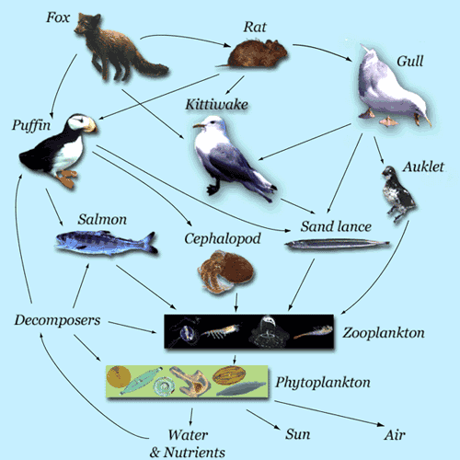
What we learned.
Phytoplankton

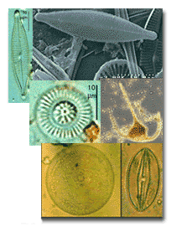
Phytoplankton are microscopic plants that drift freely with the ocean currents. They are the "producers" of the ocean because they make food for themselves by transforming energy from the sun via photosynthesis. This energy is carried up the food chain as one animal eats the next. Since phytoplankton support all other animals in the food chain, their population size and the timing of their population increases or "blooms" are important. We monitor the biomass, or amount of phytoplankton in our study areas with two different instruments. Both read the amount of chlorophyll a (the green colored plant matter that produces carbohydrates from sunlight) in the water.
We use a flourometer to measure the amount of chlorophyll a. The flourometer emits specific color wavelengths and simultaneously reads the wavelengths that travel through the water. The amount of green wavelengths that are picked up is an indirect way to measure the amount of chlorophyll a, and therefore the biomass of phytoplankton.
We also sample phytoplankton with a Niskin bottle. This instrument takes a sample of water from a particular depth and brings it to the surface. The water is put through a microscopic filter to strain out the phytoplankton, which are then put into a machine called a spectrometer. The spectrometer reads the amount of chlorophyll a in the sample and can measure phytoplankton biomass.
We can learn when and where phytoplankton blooms occur by sampling ocean study sites regularly from April through September (see What we learned, below). We also look at how salinity, temperature, and depth influences phytoplankton.
What we learned.

Zooplankton

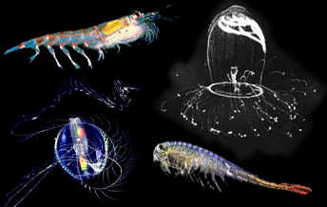
Zooplankton are tiny animals that graze upon phytoplankton as they ride the ocean currents. Protozoans, some types of copepods, worms, krill, crabs, jellyfish, and the larvae of fish and other invertebrates are all zooplankton. Zooplankton are eaten by whales, small fish, invertebrates, and birds. We try to measure how much zooplankton are in waters that surround the seabird colonies that we study. To do this, we pull a cone shaped net vertically through the water to catch the tiny animals. The zooplankton are washed off the net and stored in bottles for later examination, when we can estimate total abundance and species composition. We can compare these data between study areas, seasons and years to assess how "secondary" marine productivity changes and consider how this may impact the fish, seabirds and mammals that live there.
What we learned.

Nutrients

Nutrients in the ocean are defined as any inorganic or organic solute necessary for the nutrition and growth of phytoplankton. Nutrients in the ocean are made of nitrogen, phosphorus, carbon, sulfer, hydrogen, and oxygen. The roll that nutrients have in the ocean is best illustrated in the simplified cycle shown below. The reserve of nutrients in deeper water is constantly replenished by the decomposition of dead organisms and fecal pellets which sink and decay on the bottom of the ocean. Nutrients are brought to the surface waters by turbulence and vertical mixing. The nutrient concentrations in the water-column are depleted by phytoplankton, which require both light and nutrients for their reproduction and growth. The nutrients utilized by phytoplankton return to the ocean. The cycle begins again as phytoplankton die or are eaten by zooplankton and small fish that get rid of excess nutrients in their waste.
What we learned.

Temperature

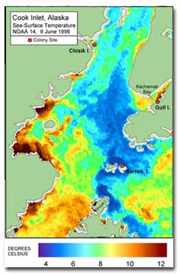
Temperatures at any point in the ocean are constantly changing with time. Over small time periods, temperatures may change as tides and currents bring new water into the area, or as solar radiation heats up surface layers. In the world’s ocean, maximum surface temperatures occur near the equator where solar energy input is the greatest. At seasonal times scales, temperatures warm during summer and cool during winter. At annual and decadal time scales, local water temperatures change as large-scale changes in oceanic currents move water masses among colder northern regions and warmer tropical regions, or bring larger volumes of deep, cold water to the surface or nearshore.
In deep ocean waters, temperature changes below the thermocline (a boundary layer of water that separates warm surface waters from cold deep ocean waters) are minimal. Vertical mixing in the water column is the only significant process by which temperature changes occur at this depth.
All animals in the ocean have a "thermal range"- the temperature range at which they can most efficiently grow, reproduce, and live. Many fish habitats are described in relation to water temperature. Capelin (an energy-dense forage fish in the Smelt family) are an example of how ocean temperatures effect fish distribution, and in turn seabird distribution and health. Capelin favor cold water. During a time period when surface waters are very warm, capelin migrate into deeper, cooler waters. When capelin are deeper in the water-column, they are less available to surface-feeding seabirds and possibly harder to obtain for diving seabirds. The absence of this nutritious fish in seabird diets may have an effect on seabird breeding success.
What we learned.

Salinity


Sea-water is a solution that is made up of much more than salt and water, and the salt in the ocean is more complex than the salt (sodium chloride, NaCl) on your dinner table. Salt in the ocean is comprised of many ions such as chlorine, sodium, calcium, potassium, magnesium, and sulfate. Salinity is the most commonly used measure of the saltiness of seawater, and is defined as the total number of grams of dissolved salt ions present in 1 kg of seawater.
Salinity concentrations vary from place to place and at different depths. Salinity is highest in the surface waters of the world's oceans and in the trade wind regions where annual evaporation exceeds precipitation. Near the surface, evaporation or precipitation may change salinity, but below the surface only mixing will alter the salinity. We are interested in the processes that concentrate or dilute the ocean in specific areas. For example, in certain bays called ‘estuaries’ there are a lot of rivers and streams that input freshwater into the ocean; thereby diluting the salinity concentrations where the rivers meet the sea. This less saline surface water may influence the distribution of fish, thereby altering the foraging strategies of seabirds.
We measure salinity using the personal CTD shown in the photo above. This apparatus is cast over the side of a reasearch boat and sent deep into the ocean. As seawater is pumped through the tube-shaped CTD, it passes a number of sensors that measure conductivity, temperature, and depth. From conductivity we can calculate salinity. All the information collected is stored in an internal data logger that is later downloaded into a computor.
What we learned.

Bathymetry

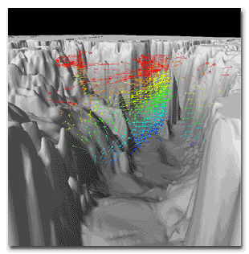
Bathymetry is a term used to describe the topography, or contour, of the ocean floor. There are deep valleys and rifts, steep mountains and hills, and flat plains and shelves- all beneath the ocean's surface. The bathymetry of an ocean, sea, or bay influences the flow of water in that area as the moving water reacts to each part of the ocean floor "landscape". The resulting change in ocean depth leads to variations in temperature, salinity and nutrient concentrations, and finally in what animals live there. In areas where deep ocean currents hit a shallow shelf on the ocean floor, all the cold, deep water is forced upwards as it makes it way over the shelf. This action brings high concentrations of nutrients from the ocean floor to the surface waters, which power marine food webs and create an abundance of food for fish, seabirds, and marine mammals. Typically, these areas of cold water upwelling are host to multitudes of seabirds and marine mammals. The mouth of Glacier Bay and Kennedy Entrance at the mouth of Cook Inlet are two such areas.
The image you see here depicts the bathymetry of central Prince William Sound viewed from Hinchinbrook Entrance. The arrows show the direction and strenth of current flow (1994 data). Image courtesy of PWS Science Center, SEA program (David Salmon and Jim Murphy, SEAOCEAN project).
What we learned.

At the end I told you all of the animal in the earth land animal or sea big or small anmals in the food chain like

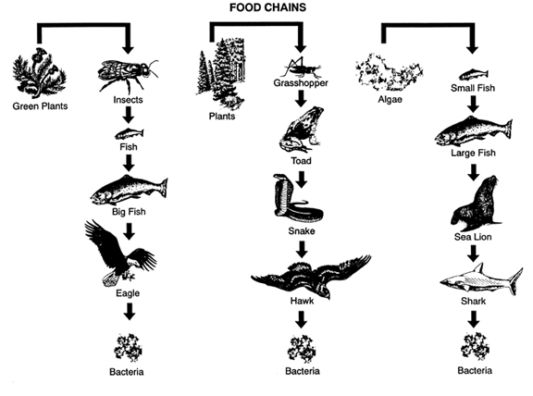
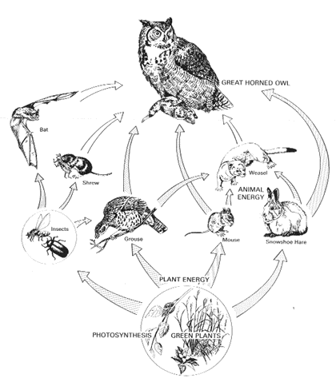

www.absc.usgs.gov/.../marinehabitat/home.html
www.stevetrash.com/lessons/foodchai.htm‎
‎www.srd.gov.ab.ca/.../owls/foodchain.aspx‎
www.mdawi.com/vb/t10844.html‎
www.livingheritage.org.nz/.../chain-gang.php‎

