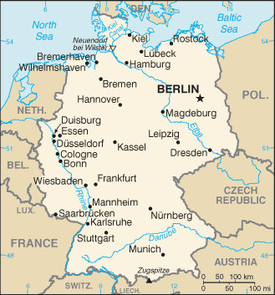
Introduction

Germany is a country in Central Europe 51 N, 9 E, and the capital is Berlin. It is bordered by nine countries, to the north by the North Sea, Denmark, and the Baltic Sea; to the east by Poland and the Czech Republic; to the south by Austria and Switzerland; and to the west by France, Luxembourg, Belgium, and the Netherlands. East and West Germany were unified in 1990.The area of Germany covers 357,021 square kilometers. The population of the country is 82,422,299.

Body
Germany’s states
Germany has 16 states they are Baden, Bavaria, Berlin, Brandenburg, Bremen, Hamburg, Hessen(Hesse), Mecklenburg-Vorpommern, Lower Saxony, North Rhine, Rhineland, Saarland, Saxony, Saxony-Anhalt, Schleswig-Holstein, and Thuringia.

Climate
Most of Germany has a temperate seasonal climate in which humid westerly winds predominate. Winters are mild and summers tend to be cool, though temperatures can exceed 30 °C (86 °F) for prolonged periods. In the east, the climate is more continental; winters can be very cold, summers can be very warm, and long dry periods are often recorded. Highest point: the Zugspitze at 2,962 meters (9,718 ft).

The languages
The spoken language in Germany is German, English and French.

Industry
Only about 6% of Germans are farmers, growing crops such as wheat, barley, rye and potatoes. Many more people work in manufacturing or service industries.

Economy
Germany is the world's third-largest economy and the largest in Europe. Most of the country's products are in engineering, especially in automobiles, machinery, metals, and chemical goods. The United States is Germany's second-largest trading partner. Major U.S. export categories include aircraft, electrical equipment, telecommunications equipment, data processing equipment, and motor vehicles and parts. German export sales are concentrated in motor vehicles, machinery, chemicals, and heavy electrical equipment.

Wall of Berlin
The wall separated East Germany from West Germany for more than a quarter-century; from the day construction began on August 13, 1961 until the Wall was opened on November 9, 1989. During this period, at least 98 people were confirmed killed trying to cross the Wall into West Berlin, according to official figures. However, a prominent victims' group claims that more than 200 people were killed trying to flee from East to West Berlin.

Conclusion

GERMANY is the seventh largest country by area in Europe and the 63rd largest in the world. Germany is recognized as a scientific and technological leader in several fields. It holds a key position in European affairs and maintains a multitude of close partnerships on a global level.

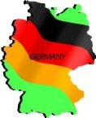

English report:

Germany

Done by: Aya Hussam
Under the supervision of teacher: Basma

INDEX
INTRODUCTION | 1
BODY | 1-2
CONCLUSION | 2

